CIVIL LAW PAPER I · ISLAMABAD HIGH COURT · CIVIL JUDGE-CUM-MAGISTRATE EXAMINATION 2026
Topic 4 · Specific Contracts and the Sale of Goods
Contract Act 1872, sections 124 to 238 — indemnity, guarantee, bailment, pledge and agency — and the Sale of Goods Act 1930
Knowledge Base — every concept in simple words, with rationale, cases, ratio decidendi and maxims

Prepared for: Ihtisham Ul Haq (Roll No. 999)
Paper: Civil Law-I — Monday, 26 October 2026, 2:00 PM to 5:00 PM (reporting 1:30 PM)
This volume: Topic 4 of 4 — Contract Act ss. 124–238 and the Sale of Goods Act 1930
Companion volumes: Topic 1 — CPC Part I · Topic 2 — CPC Part II · Topic 3 — Contract Act, general principles (ss. 1–75)
Text of the law used: Official texts as in force in Pakistan (pakistancode.gov.pk): Contract Act 1872 (updated February 2025); Sale of Goods Act 1930 (updated August 2024)

Contents
How to use this knowledge base 4
What Topic 4 covers 4
How the exam asks Topic 4 questions 5
Chapter 1 · Contract of indemnity (ss. 124, 125) 6
1.1 Meaning 6
1.2 The narrow Pakistani definition vs the wider English concept 6
1.3 Rights of the indemnity-holder — s. 125 6
1.4 Rights of the indemnifier 7
1.5 Indemnity and guarantee distinguished 7
Chapter 2 · Contract of guarantee (ss. 126 to 147) 9
2.1 Meaning 9
2.2 Essentials of a valid guarantee 9
2.3 Kinds of guarantee 10
2.4 Nature and extent of the surety's liability — s. 128 10
2.5 Discharge of the surety 12
2.6 Rights of the surety 14
Chapter 3 · Bailment (ss. 148 to 171, 180, 181) 16
3.1 Meaning 16
3.2 Kinds of bailment 17
3.3 Duties of the bailor 17
3.4 Duties of the bailee 17
3.5 Rights of the bailee 19
3.6 Termination of bailment 20
3.7 Bailee's lien — ss. 170, 171 20
3.8 Finder of goods (ss. 71, 168, 169) 21
Chapter 4 · Pledge (ss. 172 to 179) 23
4.1 Meaning 23
4.2 Pledge, hypothecation, mortgage and lien 23
4.3 Rights of the pawnee 23
4.4 Rights of the pawnor 24
4.5 Pledge by persons who are not owners 24
Chapter 5 · Agency (ss. 182 to 238) 26
5.1 Meaning 26
5.2 Who may employ and who may be an agent 26
5.3 Creation of agency 27
5.4 Kinds of agents 29
5.5 Sub-agents and substituted agents — ss. 190 to 195 29
5.6 Duties of the agent to the principal 30
5.7 Section 215 — the agent who deals on his own account 30
5.8 Rights of the agent 31
5.9 Principal and third parties 31
5.10 Personal liability of the agent — ss. 230 to 236 32
5.11 Termination of agency — ss. 201 to 210 32
Chapter 6 · The contract of sale of goods (SGA ss. 1 to 10) 35
6.1 Background and relation to the Contract Act 35
6.2 Key definitions — s. 2 35
6.3 Sale and agreement to sell — s. 4 35
6.4 Formalities — s. 5 37
6.5 Subject-matter — ss. 6 to 8 37
6.6 Price — ss. 9, 10 38
Chapter 7 · Conditions, warranties and caveat emptor (SGA ss. 11 to 17, 62) 39
7.1 Stipulations as to time — s. 11 39
7.2 Condition and warranty — s. 12 39
7.3 When a condition is treated as a warranty — s. 13 39
7.4 Implied conditions and warranties 40
7.5 Caveat emptor — the rule and its exceptions in one place 43
7.6 Exclusion of implied terms — s. 62 43
Chapter 8 · Transfer of property and risk (SGA ss. 18 to 26) 45
8.1 Why the moment of passing of property matters 45
8.2 The basic rules — ss. 18 and 19 45
8.3 The rules for ascertaining intention — ss. 20 to 24 46
8.4 Reservation of the right of disposal — s. 25 47
8.5 Risk — s. 26 47
Chapter 9 · Transfer of title — nemo dat quod non habet (SGA ss. 27 to 30) 49
9.1 The rule 49
9.2 The exceptions 50
Chapter 10 · Performance of the contract of sale — delivery and acceptance (SGA ss. 31 to 44) 53
10.1 Duties of seller and buyer — ss. 31, 32 53
10.2 Delivery — meaning and kinds 53
10.3 Rules as to delivery — ss. 33 to 40 54
10.4 Examination, acceptance and rejection — ss. 41 to 44 55
Chapter 11 · Rights of the unpaid seller against the goods (SGA ss. 45 to 54) 56
11.1 Who is an unpaid seller — s. 45 56
11.2 The rights — s. 46 56
11.3 The lien — ss. 47 to 49 57
11.4 Stoppage in transit — ss. 50 to 52 57
11.5 Effect of sub-sale or pledge by the buyer — s. 53 58
11.6 Right of resale — s. 54 58
Chapter 12 · Suits for breach and miscellaneous rules (SGA ss. 55 to 66) 60
12.1 The seller's remedies against the buyer 60
12.2 The buyer's remedies against the seller 60
12.3 Auction sales — s. 64 60
12.4 Other rules 61
Chapter 13 · Legal maxims for Topic 4 — at a glance 62
Chapter 14 · The great distinctions of Topic 4 63
Chapter 15 · Exam technique for Topic 4 65
15.1 Guarantee problems — the six questions 65
15.2 Agency problems — the five questions 65
15.3 Sale of goods problems — the four questions 65
15.4 A 3-hour plan (reminder) 66
Chapter 16 · Last-night revision sheet 67
zzTOCENDzz

How to use this knowledge base

What Topic 4 covers
Topic 3 dealt with the general principles that govern every contract. Topic 4 deals with the special contracts that the Contract Act regulates in detail, and with the Sale of Goods Act 1930, which took the law of sale out of the Contract Act. This volume covers:
- indemnity (ss. 124–125);
- guarantee — kinds, the surety's liability, discharge of the surety, and the surety's rights (ss. 126–147);
- bailment — duties of bailor and bailee, finders, and liens (ss. 148–171);
- pledge — rights of pawnor and pawnee, and pledges by non-owners (ss. 172–181);
- agency — creation, authority, ratification, sub-agents, duties and rights, liability to third parties, and termination (ss. 182–238);
- the contract of sale — sale and agreement to sell, goods, price (SGA ss. 1–10);
- conditions and warranties and caveat emptor (SGA ss. 11–17, including the Pakistani s. 16A);
- transfer of property and risk (SGA ss. 18–26);
- transfer of title — nemo dat quod non habet and its exceptions (SGA ss. 27–30);
- performance — delivery, acceptance and rejection (SGA ss. 31–44);
- the unpaid seller — lien, stoppage in transit and resale (SGA ss. 45–54); and
- suits for breach, auctions and miscellaneous rules (SGA ss. 55–66).
Each chapter follows the same pattern as Topics 1 to 3: the idea in plain words, the law (quoted), its ingredients, the rationale, case studies with ratio decidendi, maxims, the statutory illustrations, exam tips and common mistakes, and a quick recap.
ISLAMABAD-SPECIFIC LAW · Pakistani features of Topic 4
The Pakistani texts differ in places from the Indian Acts on which many textbooks are based:
- SGA s. 16A (inserted by Act XVIII of 1994): "the seller shall be under an obligation to inform the buyer of any defect in the goods sold at the time of the contract, except in a case where the defect is obviously known to the buyer" — unless the parties agree otherwise. This cuts deeply into caveat emptor.
- SGA s. 2(7): "goods" includes electricity, water and gas (Ordinance XLVII of 1962).
- SGA s. 13(2): the words treating acceptance of specific goods whose property has passed as a bar to rejection were omitted in 1962; in Pakistan only acceptance of goods in a non-severable contract converts a condition into a warranty.
- SGA s. 37(2) (1994): where excess goods are delivered and separating the contract quantity is difficult or time-consuming, the buyer may reject the whole.
- SGA s. 64A: increases or decreases of customs, excise or sales tax after the contract are added to or deducted from the price.
- Contract Act ss. 178, 178A: pledges by a mercantile agent and by a person in possession under a voidable contract (s. 19 or s. 19A) are valid in favour of a pawnee in good faith.
- The statutory illustrations are localised (Karachi, Quetta, Lahore, Rawalpindi, Islamabad) — quote them as they stand in the Pakistani text.
- A guarantee "may be either oral or written" (s. 126), but Art. 17 of the Qanun-e-Shahadat 1984 requires instruments of financial obligations to be attested by two men, or one man and two women, and Art. 79 governs their proof.

How the exam asks Topic 4 questions
Paper | What it asked (Topic 4)
KP High Court, Civil Law-I, 2026 (same syllabus as IHC) | Nemo dat quod non habet and its exceptions under the SGA; delivery — definition, types and rules
Lahore High Court, Civil Law-I, 2023 | Express and implied authority of an agent and s. 215 (agent dealing on his own account); bailment — definitions and obligations of bailor and bailee
Lahore High Court, Civil Law-I, 2022 | Short note: express and implied authority in agency
Lahore High Court, Civil Law-I, 2020 | Problem: a holding company's guarantee of its subsidiary's bank debt — validity, essentials, the bank's options and the guarantor's liability
Lahore High Court, ASJ, Civil Law-I, 2025 | Problem: guarantee vs indemnity (supplier, trader and surety; insurer of a warehouse)
Punjab University LL.B, Law of Contract, 2018–2020 | Rights and duties of bailee; finder of goods; rights of surety and discharge of surety; creation and termination of agency; sale vs agreement to sell; conditions and warranties; caveat emptor; unpaid seller; performance of a contract of sale

EXAM TIP · Quote the illustrations
The sections on guarantee, bailment and agency carry dozens of statutory illustrations — many of them almost exact past-paper problems (e.g., s. 133 illustrations on variance; s. 139 on impairing the surety's remedy; s. 215 on the agent who buys the estate himself). In the exam, with the bare Act in hand, quote the illustration that fits: it is authority the examiner cannot argue with.

Chapter 1 · Contract of indemnity (ss. 124, 125)

1.1 Meaning
"124. A contract by which one party promises to save the other from loss caused to him by the conduct of the promisor himself, or by the conduct of any other person, is called a 'contract of indemnity'."
Illustration: A contracts to indemnify B against the consequences of any proceedings which C may take against B in respect of a certain sum of 200 rupees. This is a contract of indemnity.
The person who promises to make good the loss is the indemnifier (promisor); the person protected is the indemnity-holder or indemnified (promisee).
LEGAL MAXIM · Indemnity — "to make whole"
The word comes from the Latin indemnis — unhurt. The purpose of indemnity is to restore the indemnity-holder to the position he would have been in had the loss not occurred — no more, no less.

Essentials
- Two parties — the indemnifier and the indemnity-holder.
- A promise to save from loss.
- The loss is caused by the conduct of the promisor or of any other person.
- All the essentials of a valid contract (s. 10) — free consent, competence, lawful object, consideration.
- It may be express or implied (e.g., an agent's implied right to indemnity — s. 222; a principal debtor's implied promise to indemnify the surety — s. 145).

1.2 The narrow Pakistani definition vs the wider English concept
Section 124 covers only loss caused by human conduct — of the promisor or of another person. It does not, in terms, cover loss from accidents or natural events (fire, flood, earthquake) not caused by human conduct. In English law, indemnity is wider: a promise to save another from loss however caused (Adamson v. Jarvis (1827) 4 Bing 66 — an auctioneer who sold goods on the instructions of a person who was not the owner was held entitled to be indemnified by that person against the true owner's claim).
Consequence. Contracts of insurance against fire or marine risks (loss not caused by human conduct) fall outside the literal words of s. 124. They are valid nonetheless — as contingent contracts (s. 31) and under the Insurance Ordinance 2000 — and the courts apply to them the general principles of indemnity recognised in equity. The definition in s. 124 is therefore not exhaustive.

1.3 Rights of the indemnity-holder — s. 125
"125. The promisee in a contract of indemnity, acting within the scope of his authority, is entitled to recover from the promisor— (1) all damages which he may be compelled to pay in any suit in respect of any matter to which the promise to indemnify applies; (2) all costs which he may be compelled to pay in any such suit if, in bringing or defending it, he did not contravene the orders of the promisor, and acted as it would have been prudent for him to act in the absence of any contract of indemnity, or if the promisor authorized him to bring or defend the suit; (3) all sums which he may have paid under the terms of any compromise of any such suit, if the compromise was not contrary to the orders of the promisor, and was one which it would have been prudent for the promisee to make in the absence of any contract of indemnity, or if the promisor authorized him to compromise the suit."
Right | Condition
Damages paid in a suit | The suit concerns a matter covered by the indemnity
Costs of the suit | He obeyed the promisor's orders and acted prudently, or was authorised to bring / defend the suit
Compromise sums | The compromise was not against the promisor's orders and was prudent, or was authorised

When can the indemnity-holder sue — before or after paying?
The old English rule was "indemnify means reimburse" — the holder had to pay first. Equity took a more practical view.
CASE STUDY · Gajanan Moreshwar Parelkar v. Moreshwar Madan Mantri (AIR 1942 Bom 302)
Facts. The plaintiff, at the defendant's request, mortgaged his own leasehold property to secure a debt for which the defendant was responsible, and the defendant promised to indemnify him. Before the plaintiff had paid anything, he sued the defendant to compel him to pay off the mortgage.
Held. (Chagla J) "If his liability has become absolute, he is entitled either to call upon the indemnifier to save him from that liability and pay it off, or to pay it off and sue the indemnifier." An indemnity would be of little value if the holder had to pay first and then sue.
Ratio. The indemnity-holder may sue as soon as his liability becomes absolute, even before he has actually paid.

1.4 Rights of the indemnifier
The Act is silent, but by analogy with the surety's rights (s. 141) and the doctrine of subrogation, an indemnifier who has paid steps into the shoes of the indemnity-holder and may enforce the latter's rights against the person who caused the loss. (In insurance, this is the insurer's right of subrogation.)

1.5 Indemnity and guarantee distinguished
Point | Indemnity (s. 124) | Guarantee (s. 126)
Parties | Two — indemnifier and indemnity-holder | Three — creditor, principal debtor, surety
Number of contracts | One contract | Three contracts (creditor–debtor, creditor–surety, debtor–surety implied)
Nature of liability | Primary and independent | Secondary — arises only on the principal debtor's default
Purpose | To save from loss | To secure a debt or performance of a third person
Existing debt | No existing debt needed | Presupposes a debt or liability of the principal debtor
Request | The indemnifier acts on his own account | The surety usually acts at the request of the principal debtor
After payment | Indemnifier may enforce the holder's rights against the wrongdoer (subrogation) | Surety steps into the creditor's shoes against the principal debtor (s. 140)

ILLUSTRATION · Indemnity or guarantee?
Two friends go to a shop. A says to the shopkeeper: "Let B have the goods; I will see you paid." This is an indemnity — A's liability is primary. If A says: "Let B have the goods; if he does not pay you, I will" — this is a guarantee — A's liability arises only on B's default (Birkmyr v. Darnell (1704) 1 Salk 27).

QUICK RECAP · Chapter 1 in five lines
- Indemnity: a promise to save another from loss caused by the promisor or any other person (s. 124).
- s. 124 is narrower than English law (Adamson v. Jarvis) — loss by accident is outside its words; insurance is valid as a contingent contract and under general indemnity principles.
- Holder's rights: damages, prudent costs, prudent compromises (s. 125).
- He may sue once his liability becomes absolute, before payment (Gajanan Moreshwar).
- Indemnity: two parties, primary liability; guarantee: three parties, secondary liability (Birkmyr v. Darnell).

Chapter 2 · Contract of guarantee (ss. 126 to 147)

2.1 Meaning
"126. A 'contract of guarantee' is a contract to perform the promise, or discharge the liability, of a third person in case of his default. The person who gives the guarantee is called the 'surety': the person in respect of whose default the guarantee is given is called the 'principal debtor', and the person to whom the guarantee is given is called the 'creditor'. A guarantee may be either oral or written."
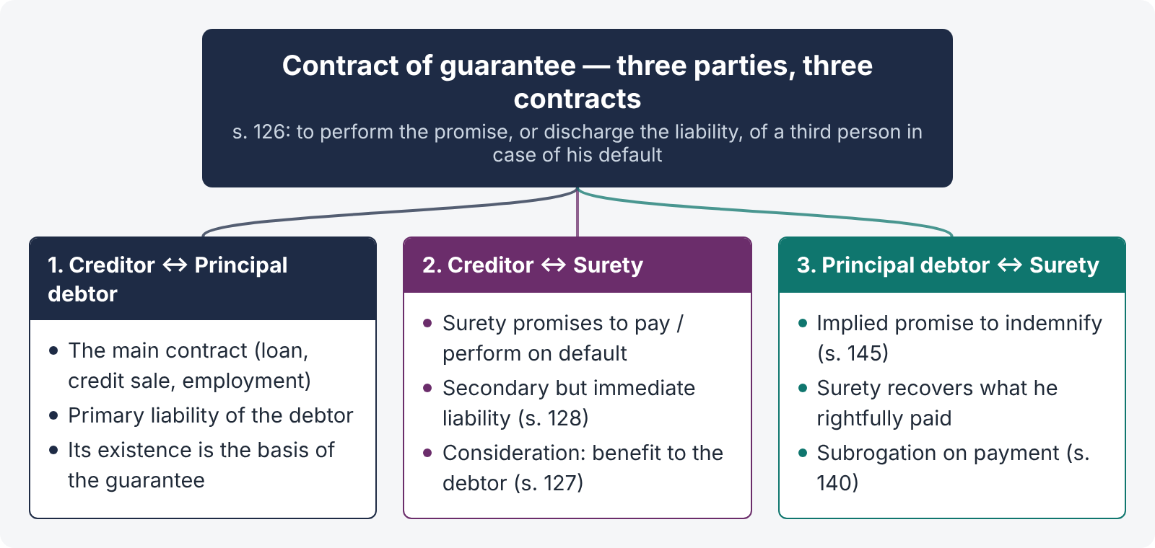
Figure 1 · The triangle of a contract of guarantee

The three contracts
- Creditor and principal debtor — the main contract (loan, sale on credit, employment).
- Creditor and surety — the surety's promise to pay or perform on default.
- Principal debtor and surety — an implied promise by the principal debtor to indemnify the surety (s. 145).

2.2 Essentials of a valid guarantee
- Three parties — creditor, principal debtor and surety, each with distinct roles.
- An existing or future liability of the principal debtor — the guarantee is collateral to a primary obligation. If there is no principal debt at all, there is nothing to guarantee.
- Consideration — s. 127: "Anything done, or any promise made, for the benefit of the principal debtor may be a sufficient consideration to the surety for giving the guarantee." The surety need not himself receive any benefit.
- Consent of all — and the surety's consent must be free: a guarantee obtained by the creditor's misrepresentation (s. 142) or concealment of material facts (s. 143) is invalid.
- Competence of the surety and creditor (ss. 11–12).
- Form — oral or written (s. 126). But as a guarantee is an instrument of financial obligation, if reduced to writing it should be attested by two men, or one man and two women (Art. 17(2)(a), Qanun-e-Shahadat 1984), and attesting witnesses are needed to prove it (Art. 79). Banks always take written, stamped guarantees.
- Condition precedent — if the surety agreed that the creditor should not act on the guarantee until a co-surety joins, and he does not join, the guarantee is not valid (s. 144).

Consideration — the illustrations to s. 127
- (a) B asks A to sell goods to him on credit; A agrees provided C guarantees payment; C promises in consideration of A's promise to deliver — sufficient.
- (b) A has already sold goods to B; C asks A to forbear to sue B for a year and promises to pay if B defaults; A agrees — sufficient (forbearance at the surety's request).
- (c) A has already sold goods to B; C afterwards, without consideration, agrees to pay if B defaults — void. (Past consideration that was not for the benefit of the principal debtor at the surety's request does not support a later guarantee.)

2.3 Kinds of guarantee
- Specific (simple) guarantee — for a single debt or transaction; ends when that debt is paid.
- Continuing guarantee — "a guarantee which extends to a series of transactions" (s. 129).
- Prospective (future debts) and retrospective (existing debts) guarantees.
- Fidelity guarantee — for the honest conduct of an employee (illustrations to s. 133).
- Bank guarantee / performance guarantee — a bank's promise to pay a beneficiary on demand (e.g., bid bonds and performance bonds in public works).

Continuing guarantee — the illustrations to s. 129
- (a) A promises B to be responsible, up to Rs. 5,000, for the due collection and payment by C of the rents of B's zamindari — continuing.
- (b) A guarantees payment to a tea-dealer, up to £100, "for any tea he may from time to time supply to C" — continuing; A is liable up to £100 for a later unpaid supply of £200.
- (c) A guarantees the price of five sacks of flour to be delivered and paid for in a month — not continuing; A is not liable for a later unpaid delivery of four sacks.

Revocation of a continuing guarantee
- By notice — "A continuing guarantee may at any time be revoked by the surety, as to future transactions, by notice to the creditor" (s. 130). The surety remains liable for transactions already entered into (illus. (a): Rs. 2,000 of bills already discounted; illus. (b): a bill already accepted before the notice).
- By the surety's death — "operates, in the absence of any contract to the contrary, as a revocation … so far as regards future transactions" (s. 131). His estate remains liable for past transactions.
- By the modes that discharge any surety (ss. 133–139 — below).

2.4 Nature and extent of the surety's liability — s. 128
"128. The liability of the surety is co-extensive with that of the principal debtor, unless it is otherwise provided by the contract."
Illustration: A guarantees to B the payment of a bill of exchange by C, the acceptor; the bill is dishonoured — A is liable not only for the amount of the bill but also for interest and charges.

What "co-extensive" means
- Not more than the principal debtor's liability — the surety is liable for no more than the debtor owes (subject to any limit in the guarantee).
- Not less (unless limited) — the surety is liable for the whole debt, with interest and charges.
- Limit by contract — the guarantee may cap the amount ("up to Rs. 5 million") or the period.
- Immediate — the surety's liability arises as soon as the principal debtor defaults. The creditor need not first sue the principal debtor or exhaust his remedies against him.
CASE STUDY · Bank of Bihar Ltd. v. Damodar Prasad (AIR 1969 SC 297)
Facts. A bank lent money to a borrower on the guarantee of a surety. On default, the trial court passed a decree against both but directed that the bank should first proceed against the principal debtor and only then against the surety.
Held. The direction was wrong. "The very object of the guarantee is defeated if the creditor is asked to postpone his remedies against the surety." The surety's liability is immediate; it is not deferred until the creditor exhausts his remedies against the principal debtor.

Where the principal debtor is not liable
- Principal debtor a minor. The minor's debt is void (Mohori Bibee). The authorities are divided. An older Bombay view (Kashiba v. Shripat Narshiv (1894) ILR 19 Bom 697) held the surety not liable because there was no valid principal debt; the better view is that, where the surety knew of the incapacity, his promise is construed as a promise to indemnify (a primary liability), so that he is liable as a principal debtor.
- Principal debt void or illegal — no liability on the surety (except as above).
- Discharge of the principal debtor by operation of law (e.g., insolvency discharge) — does not discharge the surety, because it is not the creditor's act (contrast s. 134).
- Debt time-barred against the principal debtor — the surety's liability is a separate contract; limitation runs separately against each (a suit against the surety may still be in time).

Two persons primarily liable — s. 132
Where two persons contract with a third to undertake a liability, and agree between themselves that one shall be liable only on the default of the other, the third person's rights against each are not affected — even if he knew of the internal arrangement. Illustration: A and B make a joint and several promissory note to C; A is in fact surety for B, and C knows it — this is no answer to C's suit against A.

Bank guarantees and performance bonds
A bank guarantee payable "on demand" is an independent contract between the bank and the beneficiary. The bank must pay on a demand made in terms of the guarantee, irrespective of disputes between the beneficiary and the contractor. Courts restrain encashment only in exceptional cases — established fraud of which the bank has notice, or irretrievable injustice (U.P. State Sugar Corporation v. Sumac International, (1997) 1 SCC 568). Pakistani courts follow the same approach (e.g., National Construction Ltd. v. Aiwan-e-Iqbal Authority, PLD 1994 SC 311).

2.5 Discharge of the surety
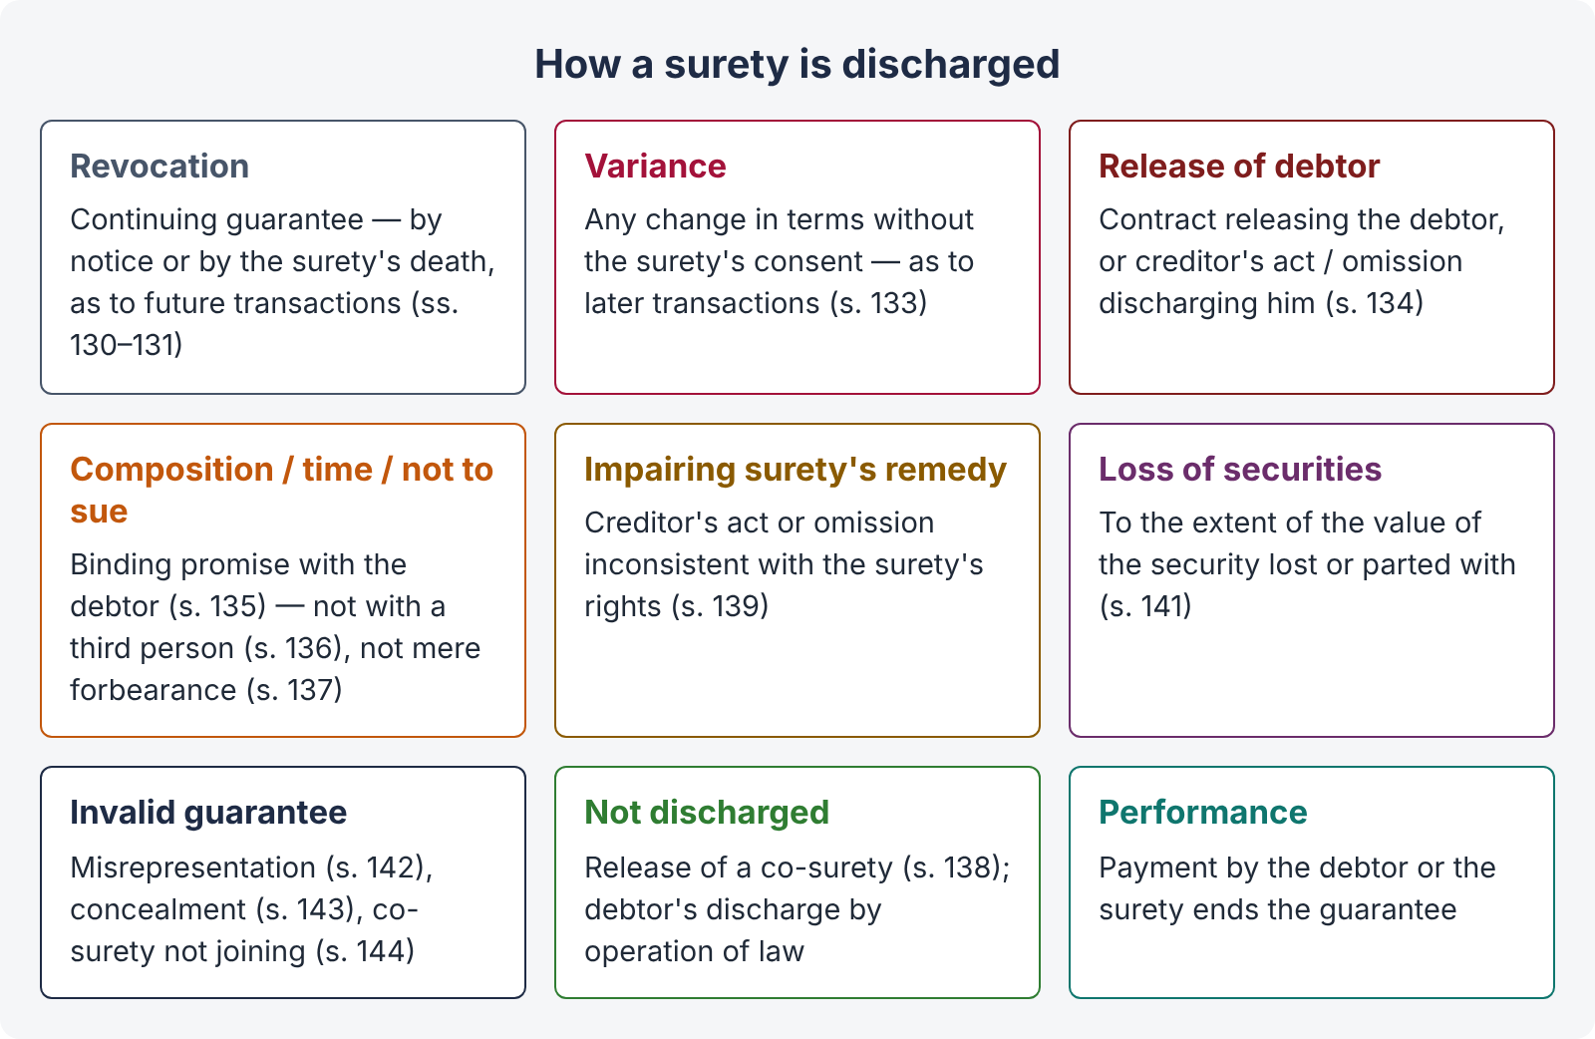
Figure 2 · How a surety is discharged

(1) By revocation — ss. 130, 131
Notice (as to future transactions) and death (as to future transactions) — for continuing guarantees only.

(2) By variance in the terms of the contract — s. 133
"133. Any variance, made without the surety's consent, in the terms of the contract between the principal debtor and the creditor, discharges the surety as to transactions subsequent to the variance."
Rationale. The surety agreed to guarantee a particular contract. The creditor and debtor cannot, behind his back, change the risk he took.
Illustrations:
- (a) A is surety for B as a bank manager; B's salary is raised and he is made liable for one-fourth of losses on overdrafts — A is discharged from later losses.
- (b) A guarantees B's conduct in an office whose duties are defined by an Act; a later Act materially alters the office — A is discharged as to the future.
- (c) B, a clerk on a fixed salary, is moved to commission — A is not liable for B's later misconduct.
- (d) A's continuing guarantee for oil supplied on credit; B and C switch to cash supplies with payments applied to old debts — A is not liable for later supplies.
- (e) C contracts to lend B Rs. 5,000 on 1 March; C pays on 1 January — A is discharged (C could now sue B before 1 March).
A variance that is not material and does not prejudice the surety, or one made with his consent, does not discharge him.

(3) By release or discharge of the principal debtor — s. 134
"134. The surety is discharged by any contract between the creditor and the principal debtor, by which the principal debtor is released, or by any act or omission of the creditor, the legal consequence of which is the discharge of the principal debtor."
Illustrations: (a) B makes a composition with his creditors (including C), assigning his property in return for release — A, the surety, is discharged; (b) B diverts a stream needed to grow the indigo A was to deliver — C, the surety for A, is discharged; (c) B fails to supply the timber needed for A to build — C, A's surety, is discharged.

(4) By composition, giving time, or promise not to sue — ss. 135–137
"135. A contract between the creditor and the principal debtor, by which the creditor makes a composition with, or promises to give time to, or not to sue, the principal debtor discharges the surety, unless the surety assents to such contract."
But:
- s. 136 — a contract to give time made with a third person, not with the principal debtor, does not discharge the surety (illus.: C, holder of an overdue bill, contracts with M to give time to B — A, the surety, is not discharged).
- s. 137 — "Mere forbearance on the part of the creditor to sue the principal debtor or to enforce any other remedy against him does not, in the absence of any provision in the guarantee to the contrary, discharge the surety." Illus.: C does not sue B for a year after the debt became payable — A is not discharged.
The difference: a binding promise to give time (s. 135) ties the creditor's hands and prevents the surety from paying and suing the debtor at once; mere inaction (s. 137) does not.

(5) Release of one co-surety — s. 138
"Where there are co-sureties, a release by the creditor of one of them does not discharge the others; neither does it free the surety so released from his responsibility to the other sureties."

(6) By the creditor's act or omission impairing the surety's eventual remedy — s. 139
"139. If the creditor does any act which is inconsistent with the rights of the surety, or omits to do any act which his duty to the surety requires him to do, and the eventual remedy of the surety himself against the principal debtor is thereby impaired, the surety is discharged."
Illustrations:
- (a) C prepays the last two instalments to B, a shipbuilder, without A's knowledge — A, B's surety, is discharged.
- (b) C sells B's furniture held as security, but through misconduct and wilful negligence realises only a small price — A is discharged.
- (c) B promised to see once a month that the apprentice M made up the cash; he omits to do so, and M embezzles — A, the surety for M's fidelity, is not liable.

(7) By loss of securities — s. 141
If the creditor loses, or without the surety's consent parts with, a security held at the time of the guarantee, "the surety is discharged to the extent of the value of the security" (s. 141; see 2.6).

(8) By invalidity of the guarantee — ss. 142–144
- s. 142 — a guarantee obtained by misrepresentation made by the creditor, or with his knowledge and assent, concerning a material part of the transaction, is invalid.
- s. 143 — a guarantee obtained by the creditor "by means of keeping silence as to material circumstances" is invalid. Illus. (a): A takes C's guarantee for clerk B's accounts without telling C that B had already failed to account — invalid. Illus. (b): B and C secretly agree that B will pay Rs. 5 per ton above market price to liquidate an old debt — concealed from the surety A — A is not liable.
- s. 144 — the co-surety who was to join does not join — not valid.
Rationale of s. 143. A guarantee is not a contract uberrimae fidei in the full sense (unlike insurance), but the creditor must disclose unusual facts about the principal debtor's past conduct or the transaction that the surety would naturally expect not to exist.

2.6 Rights of the surety

(A) Against the principal debtor
- Subrogation — s. 140. "Where a guaranteed debt has become due, or default of the principal debtor to perform a guaranteed duty has taken place, the surety, upon payment or performance of all that he is liable for, is invested with all the rights which the creditor had against the principal debtor." He steps into the creditor's shoes — including securities and priorities.
- Indemnity — s. 145. "In every contract of guarantee there is an implied promise by the principal debtor to indemnify the surety; and the surety is entitled to recover from the principal debtor whatever sum he has rightfully paid under the guarantee, but no sums which he has paid wrongfully." Illus. (a): costs of a reasonable defence — recoverable; (b): costs of an unreasonable defence — not recoverable; (c): a surety who pays Rs. 2,000 when only a smaller amount of rice was supplied can recover from B only the price of the rice actually supplied.
- Quia timet relief (in equity) — once the debt is due, the surety may ask the court to compel the principal debtor to pay the creditor, so as to relieve himself.

(B) Against the creditor
- Benefit of securities — s. 141. "A surety is entitled to the benefit of every security which the creditor has against the principal debtor at the time when the contract of suretyship is entered into, whether the surety knows of the existence of such security or not; and, if the creditor loses, or, without the consent of the surety, parts with such security, the surety is discharged to the extent of the value of the security." Illus. (a): C cancels a mortgage of B's furniture — A discharged to the value of the furniture; (b): C withdraws execution against B's goods — A discharged; (c): a further security taken after the guarantee is given up — A not discharged (it was not held at the time of the guarantee).
- Set-off — the surety may set off any debt the creditor owes to the principal debtor (where the debtor could have) or to himself.
- The discharges of ss. 133–139 operate as defences.

(C) Against co-sureties — ss. 146, 147
- s. 146 — co-sureties for the same debt, "either jointly or severally, and whether under the same or different contracts, and whether with or without the knowledge of each other", must, in the absence of contrary contract, contribute equally. Illus. (a): A, B and C, sureties for Rs. 3,000 — Rs. 1,000 each; (b): if they agreed one-quarter, one-quarter and one-half — Rs. 250, Rs. 250 and Rs. 500.
- s. 147 — co-sureties bound in different sums contribute equally so far as the limits of their respective obligations permit. Illus.: A Rs. 10,000, B Rs. 20,000, C Rs. 40,000 — on a default of Rs. 30,000, each pays Rs. 10,000; on Rs. 40,000, A pays 10,000 and B and C 15,000 each; on Rs. 70,000, each pays his full limit.
QUICK RECAP · Chapter 2 in nine lines
- Guarantee: perform the promise / discharge the liability of a third person on default (s. 126); three parties, three contracts; oral or written (attestation — Art. 17 QSO).
- Consideration: anything done for the benefit of the principal debtor (s. 127; illus. (a)–(c)).
- Kinds: specific, continuing (s. 129); revocation by notice (s. 130) or death (s. 131) as to future transactions.
- Liability co-extensive (s. 128) and immediate — no need to sue debtor first (Bank of Bihar v. Damodar Prasad); s. 132 joint promisors.
- Bank guarantees independent; injunction only for fraud / irretrievable injustice.
- Discharge: variance (s. 133), release (s. 134), composition / time / not to sue (s. 135; not s. 136 or mere forbearance s. 137), creditor impairing remedy (s. 139), loss of security (s. 141); co-surety release does not discharge (s. 138).
- Invalid guarantees: misrepresentation (s. 142), concealment (s. 143), co-surety not joining (s. 144).
- Surety's rights: subrogation (s. 140), indemnity (s. 145), securities (s. 141), set-off, quia timet.
- Co-sureties contribute equally, within their limits (ss. 146–147).

Chapter 3 · Bailment (ss. 148 to 171, 180, 181)

3.1 Meaning
"148. A 'bailment' is the delivery of goods by one person to another for some purpose, upon a contract that they shall, when the purpose is accomplished, be returned or otherwise disposed of according to the directions of the person delivering them. The person delivering the goods is called the 'bailor'. The person to whom they are delivered is called the 'bailee'. Explanation.— If a person already in possession of the goods of another contracts to hold them as a bailee, he thereby becomes the bailee, and the owner becomes the bailor, of such goods although they may not have been delivered by way of bailment."
Everyday examples: giving a car for service, clothes to a dry-cleaner, a watch for repair, luggage to a cloak-room, goods to a carrier or warehouse, a book lent to a friend, jewellery pledged with a bank.

Essentials
- Delivery of goods — only movable property (goods), not land or money as currency.
- Delivery of possession — not ownership. "The delivery to the bailee may be made by doing anything which has the effect of putting the goods in the possession of the intended bailee or of any person authorized to hold them on his behalf" (s. 149). Delivery may be actual (handing over) or constructive (e.g., handing over the keys of a godown; a person already in possession agreeing to hold as bailee — Explanation).
- For some purpose — repair, safe custody, carriage, use, security.
- Upon a contract — express or implied (the finder of goods is in a similar position by law — s. 71).
- Return of the same goods (in their original or altered form) or their disposal according to the bailor's directions.
COMMON MISTAKE · When it is not bailment
- Deposit of money in a bank — not bailment, because the bank need not return the same notes; it is a debtor–creditor relationship.
- Sale — ownership passes; no return of the same goods.
- Servant holding his master's goods — he has custody, not possession; no bailment.
- Parking a car in an open lot where the owner keeps the keys and no control passes to the lot operator — usually a licence, not bailment (it depends on whether possession and control were handed over).
- Bank locker — often treated as a lease or licence of space, since the bank has no possession of the contents; but where the bank controls access, courts have imposed a duty of care.

CASE STUDY · State of Gujarat v. Memon Mahomed Haji Hasam (AIR 1967 SC 1885)
Held. When the State seizes goods under a statute (e.g., vehicles suspected of smuggling), it holds them as a bailee — the relationship arises by operation of law, without any contract — and is bound to take reasonable care and to return them if the seizure is set aside, or pay their value.

3.2 Kinds of bailment
Basis | Kinds
Reward | Gratuitous (no charge — lending a book free) and non-gratuitous / for reward (dry-cleaning, warehousing, hire of a car).
Benefit | For the exclusive benefit of the bailor (safe custody free of charge); of the bailee (free loan of a car to a friend); of both (hire, repair for a fee, pledge).
Purpose | Deposit for safe custody; for work (repair); for carriage; for use; as security (pledge).

3.3 Duties of the bailor
- Disclose known faults — s. 150. "The bailor is bound to disclose to the bailee faults in the goods bailed, of which the bailor is aware, and which materially interfere with the use of them, or expose the bailee to extraordinary risks; and if he does not make such disclosure, he is responsible for damage arising to the bailee directly from such faults. If the goods are bailed for hire, the bailor is responsible for such damage, whether he was or was not aware of the existence of such faults." Illus. (a): A lends a horse he knows to be vicious, without telling B; B is thrown — A is liable. Illus. (b): A hires a carriage from B; it is unsafe, though B does not know — B is liable.
- Repay necessary expenses in gratuitous bailment — s. 158. Where the bailee is to receive no remuneration, "the bailor shall repay to the bailee the necessary expenses incurred by him for the purpose of the bailment".
- Extraordinary expenses — in a bailment for reward, ordinary expenses are the bailee's, but extraordinary expenses (e.g., a vet's bill for a hired horse suddenly taken ill) may be the bailor's.
- Indemnify for defective title — s. 164. "The bailor is responsible to the bailee for any loss which the bailee may sustain by reason that the bailor was not entitled to make the bailment, or to receive back the goods or to give directions, respecting them."
- Indemnify for early return of a gratuitous loan — s. 159 (below).
- Receive back the goods when the purpose is accomplished.

3.4 Duties of the bailee

(1) Duty of reasonable care — ss. 151, 152
"151. In all cases of bailment the bailee is bound to take as much care of the goods bailed to him as a man of ordinary prudence would, under similar circumstances, take of his own goods of the same bulk, quality and value as the goods bailed."
"152. The bailee, in the absence of any special contract, is not responsible for the loss, destruction or deterioration of the thing bailed, if he has taken the amount of care of it described in section 151."
Points:
- One standard for all bailments. English law graded the duty (slight care for a gratuitous bailee; great care for a borrower — Coggs v. Bernard (1703) 2 Ld Raym 909). Section 151 applies one objective standard — ordinary prudence — "in all cases of bailment", gratuitous or for reward.
- Objective test — the care a prudent man would take of his own goods of the same kind. A careless person who neglects his own goods is not excused because he treated the bailed goods the same way.
- Burden of proof — once the bailor proves the bailment and the bailee's failure to return, the burden shifts to the bailee to show that he took reasonable care (the facts are within his knowledge).
- Special contract (s. 152) — may increase the bailee's liability (e.g., to make him an insurer). Whether it may reduce liability below the s. 151 standard is doubtful; Indian courts have held that the bailee cannot contract out of the minimum duty of care.
CASE STUDY · Lily White v. R. Munuswami (AIR 1966 Mad 13)
Facts. A laundry receipt said that, for lost garments, the customer would get only 50 % of the market price. A new saree was lost.
Held. The clause was invalid. Under ss. 151–152, the bailee must take reasonable care; a clause limiting his liability in a way that encourages negligence is opposed to public policy. The customer recovered the full value.

ILLUSTRATION · Applying ss. 151–152
- Theft from a godown — a warehouseman who keeps a watchman, locks and normal precautions is not liable for a burglary that happens despite those precautions (s. 152); one who leaves the godown unguarded is.
- Riots and natural disasters — a bailee is not liable if loss occurs despite reasonable care; but if he was negligent (e.g., left goods outside in the rain, or did not move them when danger was apparent), he is liable.
- Common carriers are governed by the Carriers Act 1865, and railways by the Railways Act 1890: their liability is stricter (a common carrier is in principle an insurer, subject to the statutory exceptions).

(2) Not to make unauthorised use — ss. 153, 154
- s. 153 — "A contract of bailment is voidable at the option of the bailor, if the bailee does any act with regard to the goods bailed, inconsistent with the conditions of the bailment." Illus.: A lets a horse for B's own riding; B drives it in his carriage — A may terminate.
- s. 154 — "If the bailee makes any use of the goods bailed, which is not according to the conditions of the bailment, he is liable to make compensation to the bailor for any damage arising to the goods from or during such use of them." Illus. (a): a horse lent for B's own riding is ridden by C, a family member, carefully; it falls accidentally — B is liable. Illus. (b): a horse hired in Karachi to go to Hyderabad is ridden to Khairpur; it falls accidentally — A is liable.
Point. Under s. 154 the bailee is liable even without negligence — the unauthorised use makes him an insurer during that use.

(3) Not to mix the goods — ss. 155 to 157
Situation | Result
Mixed with consent (s. 155) | Bailor and bailee have an interest in proportion to their shares in the mixture.
Mixed without consent, separable (s. 156) | Property remains with each; the bailee bears the cost of separation and any damage. Illus.: 100 marked cotton bales mixed with B's own bales — B must separate at his cost.
Mixed without consent, not separable (s. 157) | The bailee must compensate the bailor for the loss of the goods. Illus.: a barrel of Cape flour worth Rs. 45 mixed with country flour worth Rs. 25 — B must compensate A.

(4) To return the goods — ss. 160, 161
- s. 160 — "It is the duty of the bailee to return, or deliver according to the bailor's directions, the goods bailed, without demand, as soon as the time for which they were bailed has expired, or the purpose … has been accomplished."
- s. 161 — "If, by the default of the bailee, the goods are not returned, delivered or tendered at the proper time, he is responsible to the bailor for any loss, destruction or deterioration of the goods from that time" — even without negligence.
CASE STUDY · Shaw & Co. v. Symmons & Sons ([1917] 1 KB 799)
Held. A bookbinder who kept books beyond the agreed time for return, after which they were destroyed by an accidental fire, was liable for their loss: once the bailee is in default in returning the goods, he bears the risk of their loss.

(5) To return the increase or profit — s. 163
"In the absence of any contract to the contrary, the bailee is bound to deliver to the bailor … any increase or profit which may have accrued from the goods bailed." Illus.: A leaves a cow with B; the cow has a calf — B must deliver both. Dividends on shares pledged belong to the pawnor.

(6) Not to set up an adverse title (estoppel)
A bailee cannot deny the bailor's title to the goods (Art. 115, Qanun-e-Shahadat — estoppel of tenant and licensee — applied by analogy). But where a third person claims the goods, he may apply to the court to stop delivery to the bailor and decide the title (s. 167). If the bailor has no title and the bailee, in good faith, returns the goods to him, the bailee is not liable to the true owner (s. 166). If several joint owners bail goods, the bailee may return them to one of them (s. 165).

3.5 Rights of the bailee
- Compensation for undisclosed faults (s. 150) and for the bailor's defective title (s. 164).
- Reimbursement of necessary expenses in gratuitous bailment (s. 158).
- Indemnity on early recall of a gratuitous loan (s. 159).
- Lien — particular (s. 170) or general (s. 171).
- Suit against wrongdoers — "If a third person wrongfully deprives the bailee of the use or possession of the goods bailed, or does them any injury, the bailee is entitled to use such remedies as the owner might have used …; and either the bailor or the bailee may bring a suit against a third person" (s. 180). The compensation recovered is divided according to their respective interests (s. 181).
- Deliver to one joint owner (s. 165) and protection on good-faith return to a bailor without title (s. 166).
- Interpleader / court determination when a third person claims (s. 167; s. 88 and O. XXXV CPC — Topic 2).

3.6 Termination of bailment
- Expiry of the time or accomplishment of the purpose (s. 160).
- Bailee's inconsistent act — voidable at the bailor's option (s. 153).
- Gratuitous loan recalled — "The lender of a thing for use may at any time require its return, if the loan was gratuitous, even though he lent it for a specified time or purpose. But, if, on the faith of such loan made for a specified time or purpose, the borrower has acted in such a manner that the return of the thing lent before the time agreed upon would cause him loss exceeding the benefit actually derived by him from the loan, the lender must, if he compels the return, indemnify the borrower for the amount in which the loss so occasioned exceeds the benefit so derived" (s. 159).
- Death — "A gratuitous bailment is terminated by the death either of the bailor or of the bailee" (s. 162). A bailment for reward continues.
- Destruction of the subject matter, or the bailment becoming unlawful (s. 56).

3.7 Bailee's lien — ss. 170, 171
A lien is a right to retain possession of goods until a claim is satisfied. It is a passive right — to keep, not (in general) to sell.
"170. Where the bailee has, in accordance with the purpose of the bailment, rendered any service involving the exercise of labour or skill in respect of the goods bailed, he has, in the absence of a contract to the contrary, a right to retain such goods until he receives due remuneration for the services he has rendered in respect of them."
Illus. (a): a jeweller who cuts and polishes a rough diamond may retain it until paid. Illus. (b): a tailor who has agreed to deliver the coat on completion and give three months' credit has no lien (a lien is excluded by the credit agreement).
"171. Bankers, factors, wharfingers, attorneys of a High Court and policy-brokers may, in the absence of a contract to the contrary, retain, as a security for a general balance of account, any goods bailed to them; but no other persons have a right to retain, as a security for such balance, goods bailed to them, unless there is an express contract to that effect."
Point | Particular lien (s. 170) | General lien (s. 171)
Covers | Only the specific goods on which labour or skill was spent | Any goods bailed, for the general balance of account
Who has it | Any bailee who improves the goods by labour or skill | Only bankers, factors, wharfingers, High Court attorneys and policy-brokers (or by express contract)
Basis | Service on the goods | Course of business / general account
Example | Tailor, repairer, jeweller | A bank retaining securities for an overdraft

Lien is lost by parting with possession voluntarily, by waiver, by a contract inconsistent with it (credit), or by tender of the amount due. A lien is a right of retention, not of sale — except where statute allows (e.g., ss. 169, 176; the unpaid seller under SGA s. 54).

3.8 Finder of goods (ss. 71, 168, 169)
The finder of lost goods who takes them into his custody "is subject to the same responsibility as a bailee" (s. 71).
Duties: reasonable care (s. 151); no unauthorised use; reasonable efforts to find the owner; return the goods to him.
Rights:
- No suit for compensation — "The finder of goods has no right to sue the owner for compensation for trouble and expense voluntarily incurred by him to preserve the goods and to find out the owner;"
- but he may retain the goods "against the owner until he receives such compensation;" and
- where the owner has offered a specific reward, he may sue for it and retain the goods until he receives it (s. 168).
- Right to sell — s. 169. When a thing commonly the subject of sale is lost, and the owner cannot with reasonable diligence be found, or refuses to pay the lawful charges, the finder may sell it — (1) when the thing is in danger of perishing or of losing the greater part of its value; or (2) when the finder's lawful charges amount to two-thirds of its value.
CASE STUDY · Hannah v. Peel ([1945] KB 509)
Held. A soldier who found a brooch in a house requisitioned by the army, which the owner had never occupied, was entitled to it as against the owner of the house (who had no knowledge of it); but the finder's title is good against everyone except the true owner (Armory v. Delamirie (1722) 1 Str 505 — a chimney-sweep's boy who found a jewel could recover its value from a goldsmith who refused to return it).

QUICK RECAP · Chapter 3 in eight lines
- Bailment: delivery of goods for a purpose, on a contract to return or dispose of them (s. 148); possession not ownership; delivery actual or constructive (s. 149).
- Not bailment: bank deposit of money, sale, servant's custody; State seizure creates bailment (Memon Mahomed).
- Bailor: disclose known faults — hirer liable even if unaware (s. 150); expenses in gratuitous bailment (s. 158); defective title (s. 164); s. 159 indemnity on early recall.
- Bailee: ordinary prudence in all bailments (s. 151; no liability if that care taken — s. 152; Lily White); unauthorised use — voidable, strict liability (ss. 153–154); mixing (ss. 155–157); return without demand, risk after default (ss. 160–161; Shaw v. Symmons); increase (s. 163).
- Bailee's protections: s. 165 joint owners; s. 166 good-faith return; s. 167 third-party claim; s. 180 suit against wrongdoers, s. 181 apportionment.
- Termination: time / purpose; s. 153; gratuitous recall (s. 159); death in gratuitous bailment (s. 162).
- Lien: particular (s. 170 — labour or skill; credit excludes) vs general (s. 171 — bankers, factors, wharfingers, attorneys, policy-brokers).
- Finder: bailee's duties (s. 71); retain for expenses, sue for offered reward (s. 168); sell if perishing or charges reach two-thirds (s. 169).

Chapter 4 · Pledge (ss. 172 to 179)

4.1 Meaning
"172. The bailment of goods as security for payment of a debt or performance of a promise is called 'pledge'. The bailor is in this case called the 'pawnor'. The bailee is called the 'pawnee'."
A pledge is a special kind of bailment — for security. Common examples: gold ornaments pledged with a bank for a gold loan; goods in a godown pledged to a bank, with the godown keys handed over; shares pledged to a broker.

Essentials
- Delivery of possession of goods (actual or constructive — e.g., delivery of documents of title, or the keys of the godown) to the pawnee.
- As security for a debt or the performance of a promise.
- The pawnor need not be the debtor (a third person may pledge his goods for another's debt).
- Ownership remains with the pawnor; the pawnee gets a special property — the right to retain and, on default, to sell.

4.2 Pledge, hypothecation, mortgage and lien
Point | Pledge | Hypothecation | Mortgage (of movables)
Possession | With the creditor (pawnee) | With the debtor; creditor has a charge | Ownership interest transferred to the creditor, possession may remain with the debtor
Law | Contract Act ss. 172–179 | Contract / banking practice; recovery laws (e.g., Financial Institutions (Recovery of Finances) Ordinance 2001) | Transfer of Property Act (immovables); general law
Right on default | Sue and retain, or sell on reasonable notice (s. 176) | Take possession and sell under the agreement / through court | Foreclosure / sale
Example | Gold loan | Car finance; stock hypothecated to a bank | Chattel mortgage

Pledge vs lien: a lien is only a right to retain; a pledge carries a power of sale on default (s. 176). A lien arises by law (ss. 170–171); a pledge by contract.

4.3 Rights of the pawnee
- Retain the goods — "not only for payment of the debt or the performance of the promise, but for the interest of the debt, and all necessary expenses incurred by him in respect of the possession or for the preservation of the goods" (s. 173).
- Only for that debt — "The pawnee shall not, in the absence of a contract to that effect retain the goods pledged for any debt or promise other than the debt or promise for which they are pledged; but such contract, in the absence of anything to the contrary, shall be presumed in regard to subsequent advances made by the pawnee" (s. 174).
- Extraordinary expenses incurred for preservation — recoverable from the pawnor (s. 175) (but the pawnee has no lien for them; he must sue).
- On default — s. 176:
  - sue the pawnor on the debt and retain the goods as collateral security; or
  - sell the goods on giving the pawnor reasonable notice of the sale;
  - if the proceeds are less than the amount due, the pawnor is liable for the balance; if more, the pawnee must pay over the surplus.
CASE STUDY · Lallan Prasad v. Rahmat Ali (AIR 1967 SC 1322)
Facts. The pawnee of aluminium sheets sued the pawnor for the debt, but could not return the goods, which he had already disposed of without notice.
Held. A pawnee who sues for the debt must be ready to return the pledged goods on payment. If he has disposed of them without giving reasonable notice under s. 176, he cannot recover the debt without accounting for the goods; the pawnor may resist the suit or claim their value.

Reasonable notice is mandatory. A sale without notice is a breach: the pawnee is liable for the difference between the market value and the debt.

4.4 Rights of the pawnor
- Redeem — s. 177. "If a time is stipulated for the payment of the debt …, and the pawnor makes default …, he may redeem the goods pledged at any subsequent time before the actual sale of them; but he must, in that case, pay, in addition, any expenses which have arisen from his default."
- Notice before sale (s. 176), and the surplus of sale proceeds.
- Reasonable care of the goods by the pawnee (s. 151) and return of increase (s. 163 — e.g., bonus shares).
- Suit against wrongdoers (s. 180).

4.5 Pledge by persons who are not owners
The general rule is that only the owner, or a person authorised by him, can pledge. The Act and the SGA make exceptions to protect a pawnee in good faith:
Pawnor | Rule
Mercantile agent — s. 178 | "Where a mercantile agent is, with the consent of the owner, in possession of goods or the documents of title to goods, any pledge made by him, when acting in the ordinary course of business of a mercantile agent, shall be as valid as if he were expressly authorized by the owner …; provided that the pawnee acts in good faith and has not at the time of the pledge notice that the pawnor has not authority to pledge."
Person in possession under a voidable contract — s. 178A | "When the pawnor has obtained possession of the goods pledged by him under a contract voidable under section 19 or section 19A, but the contract has not been rescinded at the time of the pledge, the pawnee acquires a good title to the goods, provided he acts in good faith and without notice of the pawnor's defect of title."
Person with a limited interest — s. 179 | "Where a person pledges goods in which he has only a limited interest, the pledge is valid to the extent of that interest" (e.g., a pawnee who re-pledges, or a hirer).
Seller or buyer in possession — SGA s. 30 | A seller who remains in possession, or a buyer who obtains possession with the seller's consent, can make a valid pledge to a person in good faith without notice (Chapter 9).
Co-owner in sole possession — SGA s. 28 (by analogy) | For sales; pledges follow the same logic where the co-owner has sole possession with consent.

QUICK RECAP · Chapter 4 in six lines
- Pledge: bailment of goods as security (s. 172); pawnor and pawnee; possession passes, ownership stays.
- Distinguish hypothecation (possession with debtor), mortgage, and lien (no power of sale).
- Pawnee: retain for debt, interest, necessary expenses (s. 173); only that debt, but subsequent advances presumed (s. 174); extraordinary expenses (s. 175).
- On default: sue and retain, or sell on reasonable notice; balance / surplus (s. 176; Lallan Prasad).
- Pawnor: redeem before actual sale with expenses (s. 177).
- Non-owners: mercantile agent (s. 178), voidable-contract possessor (s. 178A), limited interest (s. 179), seller / buyer in possession (SGA s. 30).

Chapter 5 · Agency (ss. 182 to 238)

5.1 Meaning
"182. An 'agent' is a person employed to do any act for another or to represent another in dealings with third persons. The person for whom such act is done, or who is so represented, is called the 'principal'."
The essence of agency is representation: the agent brings the principal into legal relations with third persons. What the agent does within his authority is, in law, done by the principal.
LEGAL MAXIM · Qui facit per alium facit per se — he who acts through another acts himself
The principal is bound by, and can enforce, the contracts his agent makes within his authority (s. 226). This maxim is the foundation of the whole law of agency.

Agent distinguished
Relationship | Difference from agency
Servant | A servant works under the master's control as to the manner of work and does not usually make contracts for him; an agent represents the principal in dealings with third persons. A person may be both (a salesman).
Independent contractor | Produces a result by his own methods; does not bind the employer in contracts with others.
Bailee | Holds goods for a purpose; does not represent the bailor in dealings (though one person may be both — a factor).
Trustee | Holds legal title for beneficiaries; an agent holds no title and acts in the principal's name.

5.2 Who may employ and who may be an agent
- s. 183 — "Any person who is of the age of majority … and who is of sound mind, may employ an agent." A minor cannot appoint an agent (his guardian may act for him).
- s. 184 — "As between the principal and third persons any person may become an agent, but no person who is not of the age of majority and of sound mind can become an agent, so as to be responsible to his principal." A minor agent binds the principal to third parties, but is not liable to the principal for negligence or breach.
- s. 185 — "No consideration is necessary to create an agency." (A gratuitous agent is still bound by the agent's duties.)

5.3 Creation of agency
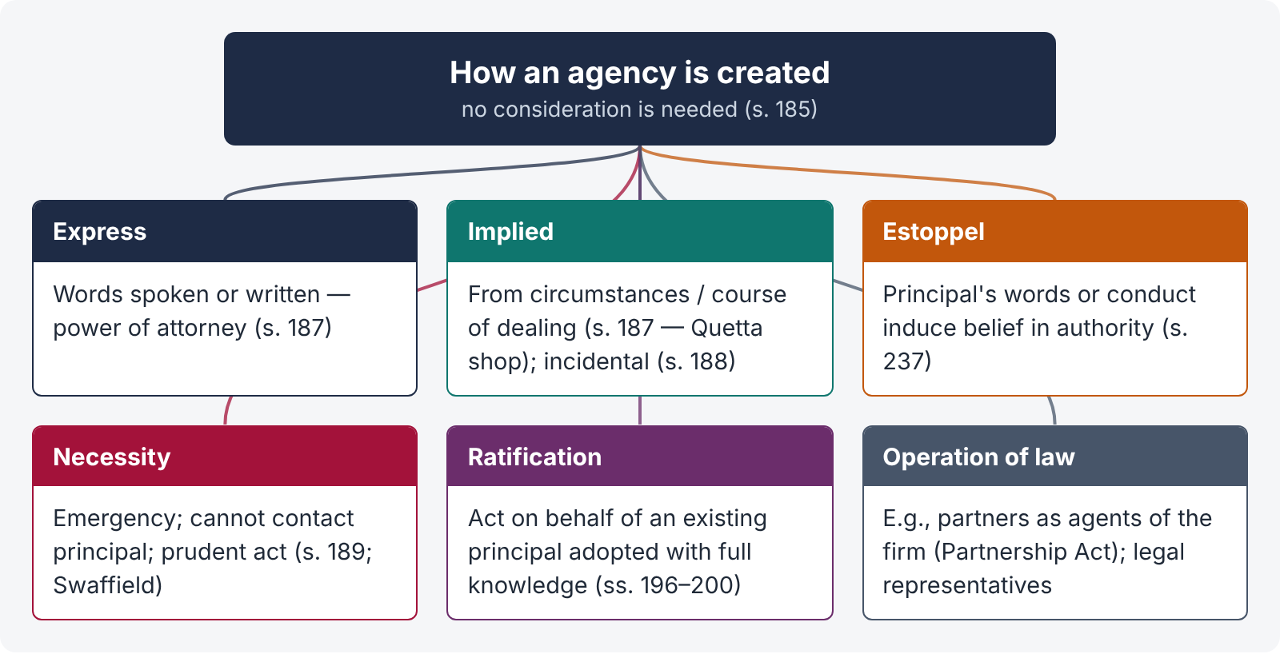
Figure 3 · How an agency is created

(1) Express agency — s. 187
Authority "given by words spoken or written" — e.g., a power of attorney, a letter of appointment, an oral instruction. A power of attorney is governed by the Powers of Attorney Act 1882 and must be properly executed (and, for registered transactions, authenticated under the Registration Act 1908, s. 33).
Construction of powers of attorney. Courts construe a power of attorney strictly: the attorney can do only what is expressly authorised and what is necessary to carry it out (s. 188). In particular, an attorney may not gift the principal's property, or sell it to himself or his relatives, unless clearly authorised — and then only with full disclosure to the principal (s. 215). Pakistani superior courts have repeatedly refused to uphold transfers made by attorneys in their own favour, or in favour of their close relatives, without the principal's informed consent (see, e.g., Fida Muhammad v. Pir Muhammad Khan, PLD 1985 SC 341).

(2) Implied agency — s. 187
Authority "inferred from the circumstances of the case; and things spoken or written, or the ordinary course of dealing, may be accounted circumstances of the case." Illustration: A owns a shop in Quetta, lives in Karachi, and visits the shop occasionally; B, who manages the shop, habitually orders goods from C in A's name and pays for them out of A's funds with A's knowledge — B has an implied authority to order goods from C.
Kinds of implied agency:
- From conduct or relationship — e.g., a wife's implied authority to buy necessaries for the household on her husband's credit (where they live together and he has not forbidden it).
- Incidental authority — s. 188. "An agent having an authority to do an act has authority to do every lawful thing which is necessary in order to do such act. An agent having an authority to carry on a business has authority to do every lawful thing necessary for the purpose, or usually done in the course of conducting such business." Illus. (a): an agent to recover a debt at Karachi may adopt any legal process and give a valid discharge; (b): an agent to carry on a shipbuilding business may buy timber and hire workmen.
- Customary authority — authority according to the usage of the trade or place (s. 211 — custom of the business).

(3) Agency by estoppel (holding out) — s. 237
"237. When an agent has, without authority, done acts or incurred obligations to third persons on behalf of his principal, the principal is bound by such acts or obligations if he has by his words or conduct induced such third persons to believe that such acts and obligations were within the scope of the agent's authority."
Illus. (a): A consigns goods to B for sale with secret instructions not to sell below a fixed price; C, ignorant of them, buys below that price — A is bound. Illus. (b): B sells negotiable instruments endorsed in blank in violation of A's private orders — the sale is good.
This is apparent or ostensible authority (Freeman & Lockyer v. Buckhurst Park Properties, [1964] 2 QB 480 — a director allowed by the board to act as managing director bound the company to architects he engaged). Its elements: (i) a representation by the principal (not the agent); (ii) reliance by the third party; (iii) change of position.

(4) Agency by necessity — s. 189
"189. An agent has authority, in an emergency, to do all such acts for the purpose of protecting his principal from loss as would be done by a person of ordinary prudence, in his own case, under similar circumstances."
Illus. (a): an agent for sale may have goods repaired if necessary. Illus. (b): A consigns provisions to B at Lahore, directing him to send them immediately to C at Rawalpindi; B may sell them at Lahore if they will not bear the journey without spoiling.
Conditions (from the cases): (i) a real emergency; (ii) it is impracticable to communicate with the principal (Springer v. Great Western Railway, [1921] 1 KB 257 — a carrier who sold tomatoes without trying to contact the owner was liable); (iii) the agent acts bona fide in the principal's interest; (iv) the action is reasonable and prudent. Classic example: Great Northern Railway v. Swaffield ((1874) LR 9 Ex 132) — a railway which stabled a horse when no one came to collect it could recover the stable charges.

(5) Agency by ratification — ss. 196 to 200
"196. Where acts are done by one person on behalf of another, but without his knowledge or authority, he may elect to ratify or to disown such acts. If he ratify them, the same effects will follow as if they had been performed by his authority."
Conditions of valid ratification:
- The act was done on behalf of the person ratifying — an agent acting for himself cannot be "ratified" (Keighley, Maxsted & Co. v. Durant, [1901] AC 240 — an undisclosed principal cannot ratify).
- The principal was in existence and competent at the time of the act (Kelner v. Baxter (1866) LR 2 CP 174 — a company cannot ratify a pre-incorporation contract; it must make a new one).
- Ratification may be express or implied (s. 197). Illus. (a): B sells to C goods bought for him without authority — implied ratification. Illus. (b): B accepts interest on a loan of his money made without authority — ratification.
- With full knowledge — "No valid ratification can be made by a person whose knowledge of the facts of the case is materially defective" (s. 198).
- Of the whole transaction — "A person ratifying any unauthorised act done on his behalf ratifies the whole of the transaction of which such act formed a part" (s. 199).
- It must not injure a third person — an act which, if authorised, would subject a third person to damages or terminate his rights, cannot by ratification be given that effect (s. 200). Illus. (a): an unauthorised demand for a chattel cannot be ratified so as to make the holder liable for refusing it. Illus. (b): an unauthorised notice to quit cannot be ratified to bind the tenant.
- Within a reasonable time, and of an act the principal could lawfully have authorised (a void or illegal act cannot be ratified).
Effect — relation back. Ratification relates back to the date of the act (Bolton Partners v. Lambert (1889) 41 Ch D 295 — the third party who had made an offer accepted by an unauthorised agent could not withdraw before the principal ratified).

5.4 Kinds of agents
- General agent (authority for all business of a kind — e.g., a manager) and special agent (for a particular act).
- Mercantile agent — "having in the customary course of business as such agent authority either to sell goods, or to consign goods for the purposes of sale, or to buy goods, or to raise money on the security of goods" (SGA s. 2(9)): factors, brokers, commission agents, auctioneers.
- Del credere agent — for an extra commission, he guarantees to the principal that the buyers he introduces will pay (a combination of agency and guarantee).
- Universal agent — unlimited authority (rare; e.g., a general power of attorney).
- Sub-agent and substituted agent (5.5).

5.5 Sub-agents and substituted agents — ss. 190 to 195
LEGAL MAXIM · Delegatus non potest delegare — a delegate cannot delegate
An agent is chosen for his personal qualities; he cannot hand over his work to another without authority.

- s. 190 — "An agent cannot lawfully employ another to perform acts which he has expressly or impliedly undertaken to perform personally, unless by the ordinary custom of trade a sub-agent may, or, from the nature of the agency, a sub-agent must, be employed."
- s. 191 — a sub-agent is "a person employed by, and acting under the control of, the original agent in the business of the agency".
- s. 192 — where properly appointed: the principal is bound by the sub-agent's acts as regards third persons; the agent is responsible to the principal for the sub-agent's acts; the sub-agent is responsible to the agent, but not to the principal, except for fraud or wilful wrong.
- s. 193 — a sub-agent appointed without authority: the agent stands as principal to him and is responsible to both principal and third persons; the principal is not bound.
- s. 194 — a substituted agent: where the agent, holding authority to name another person to act for the principal, names him, that person is not a sub-agent but the principal's own agent for that part of the business. Illus. (a): a solicitor directed to sell by auction and to employ an auctioneer names C — C is A's agent. Illus. (b): a merchant in Chittagong authorised to recover money instructs a solicitor — the solicitor is A's.
- s. 195 — in selecting a substituted agent the agent must use the discretion of a man of ordinary prudence; if he does, he is not responsible for the substitute's negligence. Illus. (a): a ship surveyor of good reputation chooses an unseaworthy ship — the surveyor, not the merchant, is liable.

5.6 Duties of the agent to the principal
s. | Duty
211 | Follow directions — or, in their absence, the custom of the business at the place; if he departs, he must make good any loss and account for any profit. Illus. (b): a broker who sells on credit where the custom is cash, to a buyer who becomes insolvent, must make good the loss.
212 | Skill and diligence — as much skill as is generally possessed by persons in similar business (unless the principal knew of his want of skill); always reasonable diligence; compensation for direct (not remote) consequences of neglect. Illus. (a): an agent in London who delays remitting money to a merchant in Islamabad is liable for the money, interest and direct loss — not for the merchant's later insolvency.
213 | Render proper accounts on demand.
214 | Communicate with the principal in cases of difficulty and seek instructions.
215 | Not deal on his own account without the principal's informed consent (5.7).
216 | Hand over secret profits — the principal may claim any benefit the agent obtained by dealing on his own account. Illus.: B tells A the house cannot be bought, buys it himself — A may compel B to sell it to him at cost.
218 | Pay over all sums received for the principal (subject to lawful deductions — s. 217).
209 | On the principal's death or insanity, take reasonable steps to protect the interests entrusted to him.
— | Not to delegate (s. 190); not to disclose confidential information; not to set up an adverse title to the principal's property.

5.7 Section 215 — the agent who deals on his own account
"215. If an agent deals on his own account in the business of the agency, without first obtaining the consent of his principal and acquainting him with all material circumstances which have come to his own knowledge on the subject, the principal may repudiate the transaction, if the case shows either that any material fact has been dishonestly concealed from him by the agent, or that the dealings of the agent have been disadvantageous to him."
Illus. (a): A directs B to sell A's estate; B buys it for himself in the name of C. A may repudiate if B dishonestly concealed a material fact or the sale was disadvantageous. Illus. (b): B, before selling, finds a mine on the estate, conceals it, and buys the estate with A's permission — A may repudiate or adopt the sale.
Rationale. The agent is a fiduciary. "No man can serve two masters": as seller for the principal he should get the highest price; as buyer for himself he wants the lowest. The law removes the temptation.
Elements for repudiation:
- The agent dealt on his own account (directly, or through a nominee or relative);
- in the business of the agency;
- without first obtaining the principal's consent after disclosing all material circumstances; and
- either a material fact was dishonestly concealed, or the dealing was disadvantageous to the principal.
Remedies: repudiate (rescind) the transaction (s. 215) or affirm it and claim the profit (s. 216) — e.g., Armstrong v. Jackson ([1917] 2 KB 822): a stockbroker instructed to buy shares sold his own shares to the client — the client could rescind and recover the price, even years later.

5.8 Rights of the agent
s. | Right
217 | Retainer — retain from sums received in the business all money due to himself for advances, expenses and remuneration.
219 | Remuneration — due on completion of the act, unless otherwise agreed; he may detain money received on account of goods sold though not all have been sold.
220 | No remuneration for misconducted business — Illus. (a): remuneration for recovering Rs. 1,00,000 and investing Rs. 90,000 well, but none for the Rs. 10,000 badly invested, and he must make good the Rs. 2,000 loss.
221 | Lien — retain the principal's goods, papers and other property (movable or immovable) received by him, until his commission, disbursements and services in respect of the same are paid.
222 | Indemnity against the consequences of all lawful acts done in exercise of his authority. Illus. (a): B, at Singapore, contracts under A's instructions; A fails to send the goods; B, defending the buyer's suit with A's authority, pays damages and costs — A must indemnify.
223 | Indemnity for acts done in good faith, even if they injure third persons. Illus. (a): a court officer who seizes goods on a decree-holder's representation and is sued by the true owner must be indemnified by the decree-holder.
224 | No indemnity for criminal acts — Illus.: A employs B to beat C, or to publish a libel — no indemnity, even if expressly promised.
225 | Compensation for injury caused by the principal's neglect or want of skill — Illus.: a bricklayer hurt by scaffolding badly put up by the employer.
205–206 | Compensation for revocation without sufficient cause of an agency for a fixed period, and for want of reasonable notice.

5.9 Principal and third parties
- General rule — s. 226. Contracts made and acts done by an agent "may be enforced in the same manner, and will have the same legal consequences, as if the contracts had been entered into and the acts done by the principal in person." Illus. (b): payment to an agent authorised to receive money discharges the payer.
- Excess of authority — ss. 227, 228. If the authorised part is separable, only that part binds the principal (illus.: insurance on the ship authorised, on the cargo not — A pays only the ship premium). If not separable, the principal may repudiate the whole (illus.: 500 sheep authorised; 500 sheep and 200 lambs bought for one sum — A may repudiate).
- Notice to the agent — s. 229. Notice or information obtained by the agent in the course of the business has the same effect as notice to the principal (illus. (a)); not information he obtained before the agency (illus. (b)).
- Agent's fraud or misrepresentation — s. 238. Misrepresentations and frauds by agents acting in the course of their business affect agreements as if made by the principal; not those outside their authority. Illus. (a): an unauthorised misrepresentation by a sales agent — the contract is voidable by C. (The principal is also liable in tort for the agent's fraud in the course of employment — Lloyd v. Grace, Smith & Co., [1912] AC 716.)

5.10 Personal liability of the agent — ss. 230 to 236
"230. In the absence of any contract to that effect, an agent cannot personally enforce contracts entered into by him on behalf of his principal, nor is he personally bound by them."
Presumed contract to the contrary (agent personally liable):
- the contract is made by an agent for the sale or purchase of goods for a merchant resident abroad;
- the agent does not disclose the name of his principal;
- the principal, though disclosed, cannot be sued (e.g., a foreign sovereign, or a minor).
Other cases of personal liability: the agent expressly agrees to be liable; he signs a negotiable instrument in his own name without indicating he signs as agent (s. 28, Negotiable Instruments Act); he acts for a principal who does not exist (pre-incorporation — Kelner v. Baxter); the agent's authority is coupled with an interest.

Undisclosed and unnamed principals
- s. 231 — where the third party neither knows nor suspects that he is dealing with an agent, the principal may require performance, but the third party has against the principal the same rights as against the agent (e.g., set-off). If the principal discloses himself before completion, the third party may refuse to fulfil the contract if he can show that he would not have contracted had he known.
- s. 232 — the principal obtains performance subject to the rights and obligations between the agent and the third party. Illus.: A, owing B Rs. 500, sells B rice worth Rs. 1,000 as C's undisclosed agent — C cannot compel B to take the rice without allowing the set-off.
- s. 233 — where the agent is personally liable, the third party may hold either him or the principal, or both, liable. Illus.: A may sue either B (the agent) or C (the principal), or both, for the price of cotton.
- s. 234 — if the third party induces the agent to act on the belief that only the principal will be liable (or vice versa), he cannot afterwards hold the other liable (election / estoppel).
- s. 235 — a pretended agent who untruly represents that he is authorised is liable to compensate the third party for loss, if the alleged principal does not ratify (breach of warranty of authority — Collen v. Wright (1857) 8 E & B 647).
- s. 236 — a person who contracts as agent but is in fact acting on his own account cannot require performance.

5.11 Termination of agency — ss. 201 to 210
"201. An agency is terminated by the principal revoking his authority; or by the agent renouncing the business of the agency; or by the business of the agency being completed; or by either the principal or agent dying or becoming of unsound mind; or by the principal being adjudicated an insolvent …"

Modes
- By act of the parties — revocation by the principal (s. 203; express or implied — s. 207: A empowers B to let his house, then lets it himself — implied revocation); renunciation by the agent; mutual agreement.
- By operation of law — completion of the business; expiry of the period; death or insanity of either; insolvency of the principal; destruction of the subject matter; the agency becoming unlawful (e.g., the principal becoming an alien enemy).

Irrevocable agency — agency coupled with interest — s. 202
"202. Where the agent has himself an interest in the property which forms the subject-matter of the agency, the agency cannot, in the absence of an express contract, be terminated to the prejudice of such interest."
Illus. (a): A authorises B to sell A's land and to pay himself out of the proceeds the debts due to him from A — A cannot revoke, nor is it terminated by A's insanity or death. Illus. (b): A consigns cotton to B, who has made advances on it, and asks B to sell and repay himself — irrevocable.
The interest must exist at the time of creation of the agency; mere expectation of commission is not such an interest.

Partly exercised authority — ss. 203, 204
The principal may revoke before the authority has been exercised so as to bind him (s. 203), but not after it has been partly exercised, as regards acts and obligations arising from acts already done (s. 204). Illus. (a): B buys cotton in his own name, becoming personally liable — A cannot revoke B's authority to pay for it out of A's money. Illus. (b): B buys in A's name without personal liability — A can revoke B's authority to pay.

Compensation and notice — ss. 205 to 206
Where the agency is for a fixed period, the party who revokes or renounces without sufficient cause must compensate the other (s. 205). Reasonable notice must be given; otherwise the resulting damage must be made good (s. 206).

When termination takes effect — ss. 208 to 210
- s. 208 — termination does not take effect as regards the agent before it becomes known to him, or as regards third persons before it becomes known to them. Illus. (a): B sells goods after A's letter of revocation is sent but before it reaches him — the sale binds A and B gets his commission. Illus. (b): C, who knew of B's original authority (to sell cotton at Karachi) but not of its revocation, pays B — the payment is good against A. Illus. (c): B pays C after A's death but before hearing of it — good against A's executor.
- s. 209 — on the principal's death or insanity, the agent must take reasonable steps to protect the interests entrusted to him.
- s. 210 — termination of the agent's authority terminates the authority of all sub-agents he appointed.
QUICK RECAP · Chapter 5 in ten lines
- Agent: employed to do an act for another or represent him with third persons (s. 182); qui facit per alium facit per se; no consideration needed (s. 185); a minor can be an agent but is not liable to the principal (s. 184).
- Creation: express or implied (ss. 186–187 — Quetta shop); incidental (s. 188); estoppel / ostensible (s. 237; Freeman & Lockyer); necessity (s. 189; Swaffield; Springer); ratification (ss. 196–200).
- Ratification: on behalf of an existing, competent principal (Keighley Maxsted; Kelner v. Baxter); full knowledge (s. 198); whole transaction (s. 199); no injury to third persons (s. 200); relates back (Bolton Partners).
- Sub-agents (ss. 190–193) vs substituted agents (ss. 194–195); delegatus non potest delegare.
- Agent's duties: directions / custom (s. 211), skill and diligence (s. 212), accounts (s. 213), communicate (s. 214), no self-dealing (s. 215), secret profits (s. 216), pay over (s. 218).
- s. 215: dealing on own account without informed consent — repudiate if dishonest concealment or disadvantage (Armstrong v. Jackson); powers of attorney construed strictly.
- Agent's rights: retainer (s. 217), remuneration (ss. 219–220), lien (s. 221), indemnity for lawful and good-faith acts (ss. 222–223), not criminal acts (s. 224), injury (s. 225).
- Principal bound as if he acted (s. 226); excess of authority separable / inseparable (ss. 227–228); notice (s. 229); agent's fraud in course of business (s. 238).
- Agent personally liable in the s. 230 cases; undisclosed principal (ss. 231–232); election (ss. 233–234); pretended agent (s. 235).
- Termination (s. 201); irrevocable when coupled with interest (s. 202); partly exercised (s. 204); compensation and notice (ss. 205–206); effective on knowledge (s. 208).

Chapter 6 · The contract of sale of goods (SGA ss. 1 to 10)

6.1 Background and relation to the Contract Act
Sections 76–123 of the Contract Act once dealt with sale of goods. They were repealed and replaced by the Sale of Goods Act 1930 (modelled on the English Sale of Goods Act 1893). The SGA "extends to the whole of Pakistan" (s. 1(2)). By s. 3, "the unrepealed provisions of the Contract Act, 1872, save in so far as they are inconsistent with the express provisions of this Act, shall continue to apply to contracts for the sale of goods" — so offer, acceptance, capacity, free consent, consideration and the rules on damages (ss. 73–74) still apply.

6.2 Key definitions — s. 2
Term | Definition (s. 2)
Buyer / seller | A person who buys or agrees to buy / sells or agrees to sell goods (s. 2(1), (13)).
Delivery | "voluntary transfer of possession from one person to another" (s. 2(2)).
Deliverable state | Such a state that the buyer would under the contract be bound to take delivery (s. 2(3)).
Document of title | Bill of lading, dock-warrant, warehouse-keeper's or wharfinger's certificate, railway receipt, delivery order, and any document used in the ordinary course of business as proof of possession or control of goods (s. 2(4)).
Future goods | Goods to be manufactured, produced or acquired by the seller after the contract (s. 2(6)).
Goods | "every kind of moveable property other than actionable claims and money; and includes electricity, water, gas, stock and shares, growing crops, grass and things attached to or forming part of the land which are agreed to be severed before sale or under the contract of sale" (s. 2(7)).
Insolvent | A person who has ceased to pay his debts in the ordinary course of business, or cannot pay them as they fall due (s. 2(8)).
Mercantile agent | An agent having in the customary course of business authority to sell, consign for sale, buy, or raise money on the security of goods (s. 2(9)).
Price | "the money consideration for a sale of goods" (s. 2(10)).
Property | "the general property in goods, and not merely a special property" — i.e., ownership (s. 2(11)).
Specific goods | Goods identified and agreed upon at the time the contract is made (s. 2(14)).

6.3 Sale and agreement to sell — s. 4
"4. (1) A contract of sale of goods is a contract whereby the seller transfers or agrees to transfer the property in goods to the buyer for a price. There may be a contract of sale between one part-owner and another. (2) A contract of sale may be absolute or conditional. (3) Where under a contract of sale the property in the goods is transferred from the seller to the buyer, the contract is called a sale, but where the transfer of the property in the goods is to take place at a future time or subject to some condition thereafter to be fulfilled, the contract is called an agreement to sell. (4) An agreement to sell becomes a sale when the time elapses or the conditions are fulfilled subject to which the property in the goods is to be transferred."

Essentials of a contract of sale
- Two parties — a buyer and a seller (one part-owner may sell to another).
- Goods — movable property within s. 2(7).
- Price — money consideration. Exchange of goods for goods is barter, not sale (though part money and part goods may be sale).
- Transfer or agreement to transfer of the general property (ownership).
- All the essentials of a valid contract (s. 3; Contract Act s. 10).
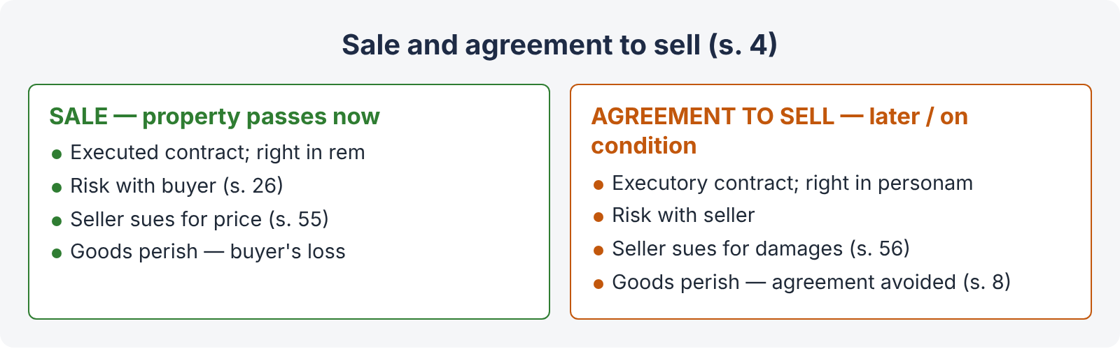
Figure 4 · Sale and agreement to sell compared
Point | Sale | Agreement to sell
Property | Passes at once to the buyer | Passes at a future time or on a condition
Nature | An executed contract; a conveyance; creates a right in rem | An executory contract; creates a right in personam
Risk (s. 26) | With the buyer (risk follows property) | With the seller
Seller's remedy on buyer's default | Suit for the price (s. 55) | Suit for damages for non-acceptance (s. 56), unless the price is payable on a fixed day (s. 55(2))
Buyer's remedy on seller's default | Ownership already his — may also claim the goods themselves (e.g., suit for possession; specific delivery) | Suit for damages for non-delivery (s. 57); specific performance in suitable cases (s. 58)
Seller's insolvency | Buyer, being owner, can claim the goods from the official receiver | Buyer is only a creditor for damages / refund
Buyer's insolvency before payment | Seller may still have lien / stoppage (ss. 46–50); otherwise must prove in insolvency | Seller may withhold the goods (s. 46(2))
Resale by seller | Buyer may follow the goods (subject to s. 30(1)) | Seller has the property; the second buyer gets title, the first buyer claims damages
Goods perish | Loss falls on the buyer | The agreement is avoided (s. 8)

Sale distinguished from similar transactions
Transaction | Difference
Barter / exchange | Goods for goods; no money price.
Gift | No price.
Bailment | Possession only, for a purpose, with return of the same goods; ownership stays with the bailor.
Hire-purchase | The hirer has an option to buy; he is not bound to buy, so he has not "bought or agreed to buy" (Helby v. Matthews, [1895] AC 471 — a hirer who pledged a piano did not pass title to the pawnbroker). Property passes only on payment of the last instalment and exercise of the option.
Contract for work and labour | The substance is skill and labour, with materials ancillary (Robinson v. Graves, [1935] 1 KB 579 — an order for a portrait was for work and labour, not sale of goods). Building contracts, repair contracts.
Mortgage, pledge, charge | A transaction "in the form of a contract of sale" intended to operate by way of security is outside the SGA (s. 66(3)).

6.4 Formalities — s. 5
"5. (1) A contract of sale is made by an offer to buy or sell goods for a price and the acceptance of such offer. The contract may provide for the immediate delivery of the goods or immediate payment of the price or both, or for the delivery or payment by instalments, or that the delivery or payment or both shall be postponed. (2) Subject to the provisions of any law for the time being in force, a contract of sale may be made in writing or by word of mouth, or partly in writing and partly by word of mouth or may be implied from the conduct of the parties."
No special form is required (subject to other laws — e.g., stamp duty on documents; Art. 17 QSO for instruments of financial obligation).

6.5 Subject-matter — ss. 6 to 8
- Existing goods — owned or possessed by the seller: specific, ascertained (identified after the contract) or unascertained (generic — "100 bags of DAP fertiliser").
- Future goods — to be manufactured, produced or acquired after the contract (s. 6(1)). "Where by a contract of sale the seller purports to effect a present sale of future goods, the contract operates as an agreement to sell" (s. 6(3)).
- Contingent goods — goods "the acquisition of which by the seller depends upon a contingency which may or may not happen" (s. 6(2)) — e.g., "the cotton I expect to receive from my farm in Sahiwal".

Perishing of goods
- s. 7 — before the contract. "Where there is a contract for the sale of specific goods, the contract is void if the goods without the knowledge of the seller have, at the time when the contract was made, perished or become so damaged as no longer to answer to their description in the contract." (Couturier v. Hastie (1856) 5 HLC 673; Contract Act s. 20.)
- s. 8 — after an agreement to sell, before risk passes. "Where there is an agreement to sell specific goods, and subsequently the goods without any fault on the part of the seller or buyer perish or become so damaged as no longer to answer to their description in the agreement before the risk passes to the buyer, the agreement is thereby avoided."
If the goods perish after property (and risk) has passed, the loss falls on the buyer (s. 26; res perit domino — the thing perishes for its owner).

6.6 Price — ss. 9, 10
- s. 9 — the price may be (1) fixed by the contract, (2) left to be fixed in a manner agreed, or (3) determined by the course of dealing. Otherwise "the buyer shall pay the seller a reasonable price", which is a question of fact.
- s. 10 — agreement to sell at the valuation of a third party: if the third party cannot or does not value, the agreement is avoided — but if the goods have been delivered to and appropriated by the buyer, he must pay a reasonable price. If the valuer is prevented by the fault of either party, the other may sue for damages.
QUICK RECAP · Chapter 6 in six lines
- SGA 1930 replaced Contract Act ss. 76–123; the Contract Act applies where not inconsistent (s. 3).
- Goods: movables except actionable claims and money; includes electricity, water, gas (Pakistan), shares, crops (s. 2(7)).
- Sale (property passes now) vs agreement to sell (future / conditional) — risk, remedies, insolvency (s. 4).
- Not sale: barter, gift, bailment, hire-purchase (Helby v. Matthews), work and labour (Robinson v. Graves), security transactions (s. 66(3)).
- No form required (s. 5); existing, future, contingent goods (s. 6); perishing before contract — void (s. 7); before risk passes — avoided (s. 8).
- Price fixed, by agreed manner, by dealing, or reasonable (s. 9); third-party valuation (s. 10).

Chapter 7 · Conditions, warranties and caveat emptor (SGA ss. 11 to 17, 62)

7.1 Stipulations as to time — s. 11
"Unless a different intention appears from the terms of the contract, stipulations as to time of payment are not deemed to be of the essence of a contract of sale. Whether any other stipulation as to time is of the essence of the contract or not depends on the terms of the contract." In commercial sales, time of delivery is usually of the essence (Topic 3, Chapter 13; Bunge v. Tradax).

7.2 Condition and warranty — s. 12
"12. (1) A stipulation in a contract of sale with reference to goods which are the subject thereof may be a condition or a warranty. (2) A condition is a stipulation essential to the main purpose of the contract, the breach of which gives rise to a right to treat the contract as repudiated. (3) A warranty is a stipulation collateral to the main purpose of the contract, the breach of which gives rise to a claim for damages but not to a right to reject the goods and treat the contract as repudiated. (4) Whether a stipulation in a contract of sale is a condition or a warranty depends in each case on the construction of the contract. A stipulation may be a condition, though called a warranty in the contract."
Point | Condition | Warranty
Importance | Essential to the main purpose | Collateral / subsidiary
Remedy | Reject the goods, treat the contract as repudiated, and claim damages | Damages only (or set-off against the price — s. 59)
Conversion | May be treated as a warranty (s. 13) | A warranty cannot become a condition
Example | Car sold as a "2023 model" is a 2015 model | A promise that the car will be serviced free for a year

7.3 When a condition is treated as a warranty — s. 13
- By the buyer's choice — s. 13(1). The buyer may waive the condition, or elect to treat the breach as a breach of warranty (keep the goods and claim damages).
- By compulsion — s. 13(2). "Where a contract of sale is not severable and the buyer has accepted the goods or part thereof, the breach of any condition to be fulfilled by the seller can only be treated as a breach of warranty … unless there is a term of the contract, express or implied, to that effect." (The Indian words "or where the contract is for specific goods, the property in which has passed to the buyer" were omitted in Pakistan in 1962 — so in Pakistan the mere passing of property in specific goods does not bar rejection; only acceptance does.)
- Impossibility — s. 13(3). The section does not affect conditions or warranties whose fulfilment is excused by law (impossibility).
Acceptance is defined in s. 42 (Chapter 10): intimation of acceptance, an act inconsistent with the seller's ownership, or retaining the goods beyond a reasonable time without rejecting them — but only after a reasonable opportunity to examine (s. 41).

7.4 Implied conditions and warranties
The SGA implies certain terms into every sale, unless excluded (s. 62).
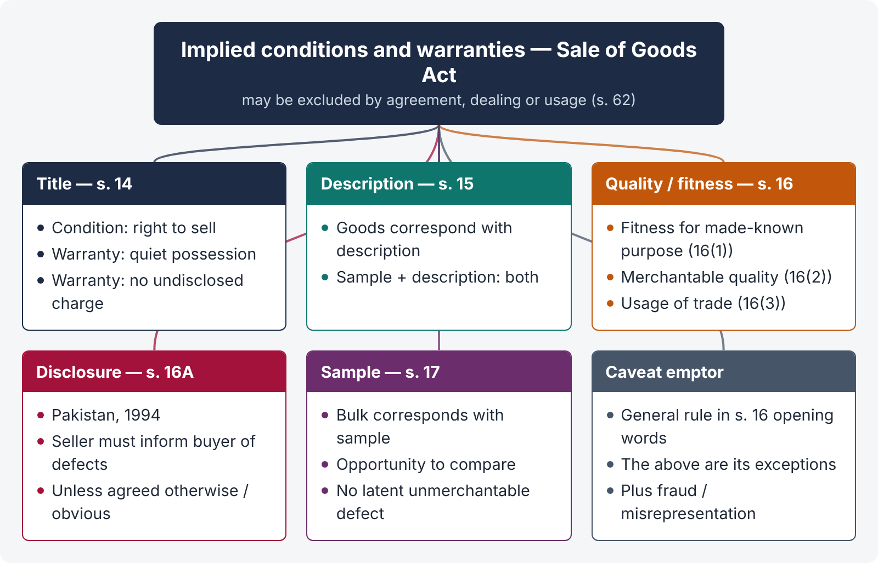
Figure 5 · Implied conditions and warranties under the Sale of Goods Act

(1) Title — s. 14
"14. In a contract of sale, unless the circumstances of the contract are such as to show a different intention there is— (a) an implied condition on the part of the seller that, in the case of a sale, he has a right to sell the goods and that, in the case of an agreement to sell, he will have a right to sell the goods at the time when the property is to pass; (b) an implied warranty that the buyer shall have and enjoy quiet possession of the goods; (c) an implied warranty that the goods shall be free from any charge or encumbrance in favour of any third party not declared or known to the buyer before or at the time when the contract is made."
CASE STUDY · Rowland v. Divall ([1923] 2 KB 500)
Facts. Rowland bought a car from Divall and used it for four months. It turned out to be stolen; the police took it back for the true owner.
Held. There was a breach of the condition as to title. Rowland could recover the whole price, without any deduction for the four months' use: there was a total failure of consideration, because he had paid for ownership and got none.

CASE STUDY · Niblett Ltd. v. Confectioners' Materials Co. ([1921] 3 KB 387)
Held. Tins of condensed milk labelled "Nissly" infringed the trade mark of Nestlé, so the buyers could not sell them without being restrained. The seller had no "right to sell" within the title condition, though he owned the tins.

(2) Sale by description — s. 15
"15. Where there is a contract for the sale of goods by description, there is an implied condition that the goods shall correspond with the description; and, if the sale is by sample as well as by description it is not sufficient that the bulk of the goods corresponds with the sample if the goods do not also correspond with the description."
- Varley v. Whipp ([1900] 1 QB 513) — a second-hand reaping machine described as "new the previous year and only used to cut 50 or 60 acres" was in fact very old — the buyer could reject.
- Beale v. Taylor ([1967] 1 WLR 1193) — a car advertised as a "1200, white, 1961" was in fact two halves welded together — breach of description, even though the buyer had seen it.
- Re Moore & Co. and Landauer & Co. ([1921] 2 KB 519) — tinned fruit to be packed in cases of 30 tins delivered partly in cases of 24 — breach of description; the buyer could reject, though the total quantity and value were correct.

(3) Quality and fitness — s. 16 (and caveat emptor)
"16. Subject to the provisions of this Act and of any other law for the time being in force, there is no implied warranty or condition as to the quality or fitness for any particular purpose of goods supplied under a contract of sale, except as follows— (1) Where the buyer, expressly or by implication, makes known to the seller the particular purpose for which the goods are required, so as to show that the buyer relies on the seller's skill or judgment, and the goods are of a description which it is in the course of the seller's business to supply (whether he is the manufacturer or producer or not), there is an implied condition that the goods shall be reasonably fit for such purpose: Provided that, in the case of a contract for the sale of a specified article under its patent or other trade name, there is no implied condition as to its fitness for any particular purpose. (2) Where goods are bought by description from a seller who deals in goods of that description (whether he is the manufacturer or producer or not), there is an implied condition that the goods shall be of merchantable quality: Provided that, if the buyer has examined the goods, there shall be no implied condition as regards defects which such examination ought to have revealed. (3) An implied warranty or condition as to quality or fitness for a particular purpose may be annexed by the usage of trade. (4) An express warranty or condition does not negative a warranty or condition implied by this Act unless inconsistent therewith."
LEGAL MAXIM · Caveat emptor — let the buyer beware
The opening words of s. 16 state the rule: there is no implied condition as to quality or fitness. The buyer must examine the goods and satisfy himself; if he buys unsuitable goods, he cannot blame the seller. The rest of s. 16 — and, in Pakistan, s. 16A — are the exceptions.

Fitness for purpose — s. 16(1). Conditions: (i) the buyer makes known the particular purpose (for goods with only one obvious purpose — milk, a hot-water bottle — the purpose is made known by implication); (ii) he relies on the seller's skill or judgment; (iii) the goods are of a kind the seller deals in.
CASE STUDY · Priest v. Last ([1903] 2 KB 148)
Facts. A man bought a hot-water bottle from a chemist, asking whether it would stand boiling water. It burst after five days and scalded his wife.
Held. A hot-water bottle has only one purpose, which was therefore made known by implication; the buyer relied on the seller; the seller dealt in such goods. There was a breach of the condition of fitness for purpose.

CASE STUDY · Grant v. Australian Knitting Mills Ltd. ([1936] AC 85, Privy Council)
Facts. Dr Grant bought woollen underwear which contained an excess of sulphites, a hidden defect. He developed severe dermatitis.
Held. There was a breach of the conditions of fitness for purpose (the purpose — to be worn next to the skin — was implied) and of merchantable quality (the defect was latent and could not be discovered by ordinary examination). "Merchantable" means that the goods are in such a state that a buyer, fully acquainted with the facts, would buy them without abatement of price and without special terms.

CASE STUDY · Frost v. Aylesbury Dairy Co. ([1905] 1 KB 608)
Held. A dairy that supplied milk containing typhoid germs was liable for breach of fitness for purpose, although it had taken all reasonable precautions — the condition is strict, not based on negligence.

The trade-name proviso. Where an article is sold "under its patent or other trade name", there is no implied condition as to fitness for a particular purpose. But the proviso applies only where the buyer does not rely on the seller's skill — where the buyer relies on the seller, despite naming a brand, the condition applies (Baldry v. Marshall, [1925] 1 KB 260 — the buyer asked for a car suitable for touring and was recommended a Bugatti; it was unsuitable — the seller was liable).
Merchantable quality — s. 16(2). Conditions: (i) sale by description; (ii) by a seller who deals in such goods; (iii) the goods are not merchantable — not saleable as goods of that description at the normal price. Examination proviso: if the buyer examined the goods, there is no condition as to defects that examination ought to have revealed — but latent defects are still covered (Grant).

(4) Pakistan's s. 16A — the duty to disclose defects
"16A. Notwithstanding anything contained in section 16, and save where the parties have entered into an agreement to the contrary, the seller shall be under an obligation to inform the buyer of any defect in the goods sold at the time of the contract, except in a case where the defect is obviously known to the buyer." (Inserted by Act XVIII of 1994.)
Significance. In England and India, mere silence about a defect is not fraud and does not make the seller liable (Contract Act s. 17 Explanation; Smith v. Hughes). In Pakistan, s. 16A makes disclosure of known (and, on its wording, any) defects a legal obligation of the seller, "notwithstanding" s. 16. The exceptions are: (i) the parties' agreement to the contrary (e.g., an "as is where is" sale); and (ii) a defect obviously known to the buyer. Breach of s. 16A gives the buyer a claim (at least for damages; and where the non-disclosure goes to the root, rejection) and is strong evidence of fraud by concealment. This is the most important Pakistani modification of caveat emptor. It is also in line with the Islamic principle of khiyar al-'aib (the buyer's option for a defect), under which a seller must not conceal defects in what he sells.

(5) Sale by sample — s. 17
A sale is by sample where there is a term, express or implied, to that effect (s. 17(1)). There are implied conditions (s. 17(2)):
- the bulk shall correspond with the sample in quality;
- the buyer shall have a reasonable opportunity of comparing the bulk with the sample;
- the goods shall be free from any defect, rendering them unmerchantable, which would not be apparent on reasonable examination of the sample (Drummond v. Van Ingen (1887) 12 App Cas 284 — cloth that matched the sample but had a latent defect in its weave that made it unfit for the buyers' trade).
If the sale is by sample and description, the goods must correspond with both (s. 15).

(6) Usage of trade — s. 16(3)
An implied condition or warranty as to quality or fitness may be annexed by the usage of trade (e.g., a custom in the cotton trade that bales will be of a certain grade).

7.5 Caveat emptor — the rule and its exceptions in one place
Exception | Law
Fitness for a particular purpose made known, reliance on seller | s. 16(1) (Priest v. Last; Grant; Baldry v. Marshall)
Merchantable quality in a sale by description by a dealer | s. 16(2) (latent defects even after examination)
Usage of trade | s. 16(3)
Sale by description | s. 15 (Varley v. Whipp; Beale v. Taylor)
Sale by sample | s. 17 (Drummond v. Van Ingen)
Duty to disclose defects (Pakistan) | s. 16A (unless excluded by agreement or obviously known)
Fraud or misrepresentation by the seller; active concealment | Contract Act ss. 17–19; SGA s. 3
Implied condition / warranties as to title | s. 14

7.6 Exclusion of implied terms — s. 62
"Where any right, duty or liability would arise under a contract of sale by implication of law, it may be negatived or varied by express agreement or by the course of dealing between the parties, or by usage, if the usage is such as to bind both parties to the contract."
Courts construe exclusion clauses strictly (contra proferentem): a clause excluding warranties does not exclude conditions (Wallis, Son & Wells v. Pratt and Haynes, [1911] AC 394 — seed sold as "common English sainfoin" turned out to be giant sainfoin; a clause excluding "any warranty" did not protect the seller from breach of the condition of description). Consumer laws (e.g., the Islamabad Consumers Protection Act 1995) may also limit exclusions.
QUICK RECAP · Chapter 7 in eight lines
- Time of payment not of essence unless intended; other time stipulations — terms (s. 11).
- Condition: essential, reject + damages; warranty: collateral, damages only; construction decides (s. 12).
- s. 13: buyer may waive / elect; after acceptance in a non-severable contract only a warranty claim (Pakistani text omits the "property passed in specific goods" bar).
- Title: condition of right to sell; warranties of quiet possession and freedom from encumbrance (s. 14; Rowland v. Divall; Niblett).
- Description (s. 15; Varley v. Whipp; Beale v. Taylor; Re Moore & Landauer).
- Caveat emptor (s. 16 opening) — exceptions: fitness (Priest v. Last; Frost; trade-name proviso, Baldry v. Marshall), merchantable quality (Grant), usage, sample (s. 17; Drummond).
- s. 16A (Pakistan, 1994): seller must inform buyer of defects unless agreed otherwise or obviously known.
- Exclusion by agreement, dealing or usage (s. 62), construed strictly (Wallis v. Pratt).

Chapter 8 · Transfer of property and risk (SGA ss. 18 to 26)

8.1 Why the moment of passing of property matters
"Property" in the SGA means ownership (s. 2(11)). The time at which property passes from seller to buyer decides:
- Risk — risk passes with property (s. 26): res perit domino.
- Remedies — the seller can sue for the price only when property has passed (s. 55(1)); otherwise for damages (s. 56).
- Insolvency — whether the goods belong to the buyer's or the seller's estate.
- Third parties — whether a creditor of the seller can attach the goods; whether the buyer can resell.
LEGAL MAXIM · Res perit domino — the thing perishes for its owner
Whoever owns the goods when they are lost or damaged bears the loss, unless the parties agree otherwise.

8.2 The basic rules — ss. 18 and 19
- Unascertained goods — s. 18. "Where there is a contract for the sale of unascertained goods, no property in the goods is transferred to the buyer unless and until the goods are ascertained." (Healy v. Howlett & Sons [1917] 1 KB 337 — 20 boxes of mackerel from a larger consignment of 190 had not been set aside for the buyer when they went bad; property and risk had not passed.)
- Specific or ascertained goods — s. 19. Property passes "at such time as the parties to the contract intend it to be transferred". To find the intention, "regard shall be had to the terms of the contract, the conduct of the parties and the circumstances of the case" (s. 19(2)). "Unless a different intention appears", the rules in ss. 20–24 apply (s. 19(3)).
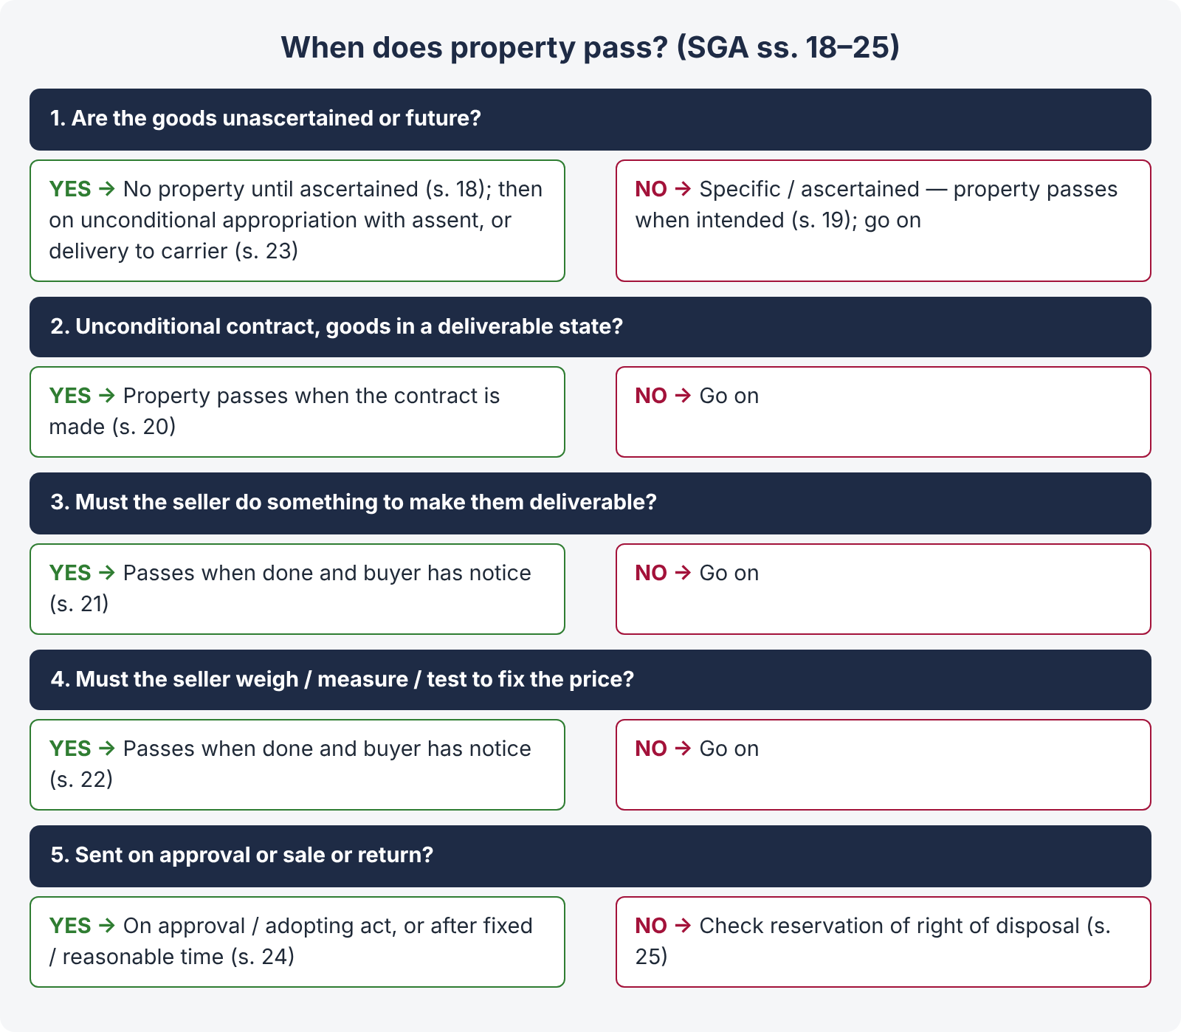
Figure 6 · When does property pass? Sections 18 to 25

8.3 The rules for ascertaining intention — ss. 20 to 24
s. | Situation | Property passes
20 | Unconditional contract for specific goods in a deliverable state | When the contract is made — even if payment or delivery, or both, are postponed.
21 | Specific goods; the seller must do something to put them into a deliverable state | When that thing is done and the buyer has notice of it. (Underwood Ltd. v. Burgh Castle Brick & Cement Syndicate [1922] 1 KB 343 — a 30-ton engine to be dismantled and loaded by the seller was damaged while being loaded; property had not passed.)
22 | Specific goods in a deliverable state; the seller must weigh, measure or test them to ascertain the price | When that act is done and the buyer has notice.
23 | Unascertained or future goods by description | When goods of that description, in a deliverable state, are unconditionally appropriated to the contract by one party with the assent of the other (express or implied, before or after). Delivery to a carrier for transmission to the buyer, without reserving the right of disposal, is an unconditional appropriation (s. 23(2)).
24 | Goods sent on approval or "sale or return" | (a) When the buyer signifies approval or does an act adopting the transaction (e.g., pledging the goods — Kirkham v. Attenborough [1897] 1 QB 201); (b) if he retains them without notice of rejection — on the expiry of the fixed time, or of a reasonable time (Poole v. Smith's Car Sales [1962] 1 WLR 744).

8.4 Reservation of the right of disposal — s. 25
- The seller may, by the terms of the contract or appropriation, reserve the right of disposal until conditions (usually payment) are fulfilled. Property then does not pass, even after delivery to the buyer or a carrier (s. 25(1)) — the basis of "retention of title" clauses.
- Where goods are shipped or sent by railway and the bill of lading or railway receipt is made deliverable to the order of the seller or his agent, the seller is prima facie deemed to reserve the right of disposal (s. 25(2), as substituted in Pakistan in 1962).
- Where the seller draws a bill of exchange on the buyer and sends it with the bill of lading or railway receipt, the buyer must return the documents if he does not honour the bill; if he wrongfully retains them, property does not pass to him (s. 25(3)).

8.5 Risk — s. 26
"26. Unless otherwise agreed, the goods remain at the seller's risk until the property therein is transferred to the buyer, but when the property therein is transferred to the buyer, the goods are at the buyer's risk whether delivery has been made or not: Provided that, where delivery has been delayed through the fault of either buyer or seller, the goods are at the risk of the party in fault as regards any loss which might not have occurred but for such fault: Provided also that nothing in this section shall affect the duties or liabilities of either seller or buyer as a bailee of the goods of the other party."
Points:
- Risk follows property, not possession — unless the parties agree otherwise (risk may pass before or after property: Sterns Ltd. v. Vickers Ltd. [1923] 1 KB 78 — buyer of part of a quantity of spirit in a tank bore the risk of deterioration though property had not passed).
- Delay — the party at fault bears the risk of loss caused by the delay (Demby Hamilton & Co. v. Barden [1949] 1 All ER 435 — buyer who delayed taking delivery of apple juice bore the risk when it went bad).
- A party holding the other's goods is still a bailee and must take reasonable care (Contract Act s. 151).
- Goods in transit — where the seller agrees to deliver at a distant place at his own risk, the buyer still bears risk of deterioration necessarily incident to transit (s. 40); where goods go by sea, the seller must give notice enabling the buyer to insure, or the goods are at his risk (s. 39(3)).
ILLUSTRATION · Who bears the loss?
On 1 June, Kamran agrees to buy from Waseem a specific used car parked in Waseem's showroom in Blue Area for Rs. 4 million, delivery and payment on 5 June. On 3 June the car is destroyed in a fire, without anyone's fault. The contract was unconditional, for specific goods in a deliverable state — property passed on 1 June (s. 20), and risk with it (s. 26). Kamran must pay the price (s. 55(1)), though he got nothing. If Waseem had agreed to repaint the car before delivery and had not done so, property would not have passed (s. 21), the loss would fall on Waseem, and the agreement would be avoided (s. 8).

QUICK RECAP · Chapter 8 in five lines
- Property = ownership; its passing decides risk, remedies, insolvency and third-party rights; res perit domino.
- Unascertained goods — no property until ascertained (s. 18; Healy v. Howlett); specific goods — as intended (s. 19).
- Rules: specific + deliverable + unconditional — at contract (s. 20); to be put in deliverable state — when done and notice (s. 21; Underwood); to ascertain price — when done and notice (s. 22); unascertained — unconditional appropriation with assent; carrier (s. 23); approval / sale or return (s. 24; Kirkham v. Attenborough).
- Reservation of right of disposal; order bills of lading / railway receipts (s. 25).
- Risk follows property unless agreed; delay — party at fault; bailee's duty preserved (s. 26; Demby Hamilton).

Chapter 9 · Transfer of title — nemo dat quod non habet (SGA ss. 27 to 30)

9.1 The rule
LEGAL MAXIM · Nemo dat quod non habet — no one can give what he does not have
A person who is not the owner cannot transfer a better title than he himself has. The buyer from a thief, or from a person who merely holds the goods, gets no ownership against the true owner.

"27. Subject to the provisions of this Act and of any other law for the time being in force, where goods are sold by a person who is not the owner thereof and who does not sell them under the authority or with the consent of the owner, the buyer acquires no better title to the goods than the seller had, unless the owner of the goods is by his conduct precluded from denying the seller's authority to sell: Provided that, where a mercantile agent is, with the consent of the owner, in possession of the goods or of a document of title to the goods, any sale made by him, when acting in the ordinary course of business of a mercantile agent, shall be as valid as if he were expressly authorised by the owner of the goods to make the same; provided that the buyer acts in good faith and has not at the time of the contract of sale notice that the seller has not authority to sell."
Rationale and the conflict. The law must choose between two innocent persons — the owner who lost his goods and the buyer who paid for them in good faith. The rule protects ownership ("security of property"); the exceptions protect commerce ("security of transactions") where the owner has contributed to the situation, or where commercial necessity demands it.
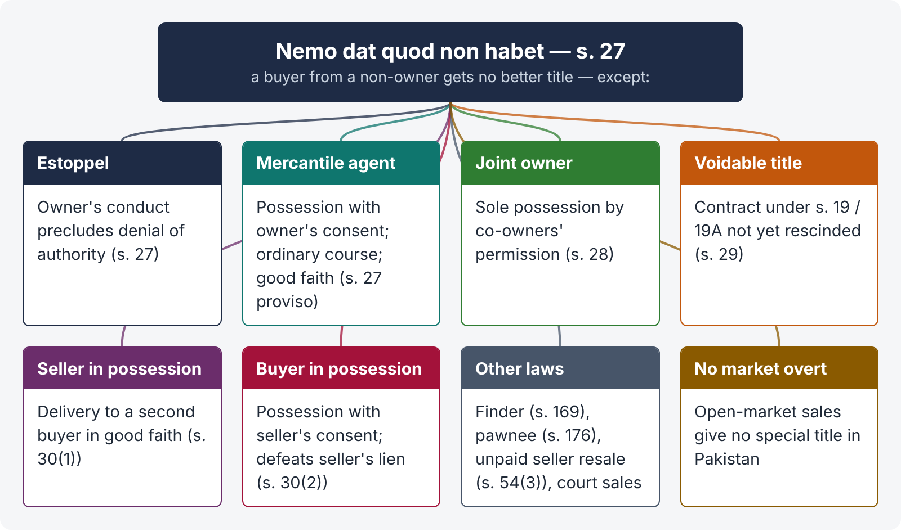
Figure 7 · Nemo dat — the rule and its exceptions

9.2 The exceptions

(1) Estoppel — s. 27 (main part)
The owner is "by his conduct precluded from denying the seller's authority to sell" — where he has held out the seller as owner or as having authority (by words or conduct), and the buyer acted on it.
- Eastern Distributors Ltd. v. Goldring ([1957] 2 QB 600) — the owner of a van signed documents enabling a dealer to represent that the van was the dealer's; the finance company that bought it in good faith got title.
- Mere possession of goods by the seller is not enough for estoppel; nor is mere carelessness in losing them (Central Newbury Car Auctions v. Unity Finance [1957] 1 QB 371 — handing over a car and its registration book to a fraudster did not estop the owner).

(2) Sale by a mercantile agent — s. 27 proviso (and Contract Act s. 178 for pledges)
Conditions:
- The seller is a mercantile agent (s. 2(9));
- he is in possession of the goods or documents of title with the consent of the owner — consent obtained by fraud is still consent (Folkes v. King [1923] 1 KB 282), but possession must be held as mercantile agent (Pearson v. Rose & Young [1951] 1 KB 275 — where the car was handed over without its registration book, the sale with the book obtained by trickery did not pass title);
- he sells in the ordinary course of business of a mercantile agent (at business premises, in business hours, in the normal way);
- the buyer acts in good faith and without notice of the lack of authority.

(3) Sale by one of joint owners — s. 28
"If one of several joint owners of goods has the sole possession of them by permission of the co-owners, the property in the goods is transferred to any person who buys them of such joint owner in good faith and has not at the time of the contract of sale notice that the seller has not authority to sell."

(4) Sale by a person in possession under a voidable contract — s. 29
"When the seller of goods has obtained possession thereof under a contract voidable under section 19 or section 19A of the Contract Act, 1872, but the contract has not been rescinded at the time of the sale, the buyer acquires a good title to the goods, provided he buys them in good faith and without notice of the seller's defect of title."
- Phillips v. Brooks Ltd. ([1919] 2 KB 243) — a rogue who obtained a ring by impersonation in a face-to-face sale had a voidable title; the pawnbroker who took it in good faith before rescission got good title. Similarly Lewis v. Averay ([1972] 1 QB 198).
- Contrast Cundy v. Lindsay ((1878) 3 App Cas 459) — where the contract is void for mistake as to identity, the rogue gets no title at all and s. 29 does not apply.
- The owner must rescind before the resale — e.g., by informing the police, where the rogue cannot be found (Car and Universal Finance Co. v. Caldwell [1965] 1 QB 525).

(5) Seller in possession after sale — s. 30(1)
"Where a person, having sold goods, continues or is in possession of the goods or of the documents of title to the goods, the delivery or transfer by that person or by a mercantile agent acting for him, of the goods or documents of title under any sale, pledge or other disposition thereof to any person receiving the same in good faith and without notice of the previous sale shall have the same effect as if the person making the delivery or transfer were expressly authorised by the owner of the goods to make the same."
The first buyer, who left the goods with the seller, loses to the second buyer who took delivery in good faith; the first buyer's remedy is against the seller (Pacific Motor Auctions v. Motor Credits [1965] AC 867, PC).

(6) Buyer in possession — s. 30(2)
"Where a person, having bought or agreed to buy goods, obtains, with the consent of the seller, possession of the goods or the documents of title to the goods, the delivery or transfer by that person … under any sale, pledge or other disposition thereof to any person receiving the same in good faith and without notice of any lien or other right of the original seller in respect of the goods shall have effect as if such lien or right did not exist."
This defeats the unpaid seller's lien or reserved right of disposal, where the buyer has possession with his consent (Newtons of Wembley v. Williams [1965] 1 QB 560). It does not apply to a hirer under hire-purchase, who has not "bought or agreed to buy" (Helby v. Matthews).

(7) Other exceptions under other laws
- Finder of goods — may sell in the cases in Contract Act s. 169.
- Pawnee — may sell on default after reasonable notice (Contract Act s. 176); pledges by mercantile agents and voidable-title holders (ss. 178, 178A).
- Unpaid seller — resale after lien or stoppage gives the new buyer good title (SGA s. 54(3)).
- Court sales — a purchaser at an execution sale (CPC O. XXI) gets the judgment-debtor's title, subject to the rules on setting aside (Topic 2).
- Negotiable instruments — a holder in due course gets good title despite defects in his transferor's title (Negotiable Instruments Act ss. 9, 58).
- Official receivers / liquidators selling under statutory powers.
No market overt in Pakistan. The old English rule that a buyer in good faith in an open market ("market overt") got good title has no counterpart in the Pakistani SGA.
ILLUSTRATION · A stolen motorbike
A thief steals Ali's motorbike in G-9 and sells it to Bashir, who buys in good faith from a roadside dealer. Ali traces it. Nemo dat applies — the thief had no title, so Bashir has none (s. 27). None of the exceptions apply: the thief was not a mercantile agent in possession with Ali's consent, there was no voidable contract (s. 29), and Ali did not hold the thief out as owner (estoppel). Bashir must return the bike and sue the thief (and the dealer, for breach of the condition as to title, s. 14(a); Rowland v. Divall).

QUICK RECAP · Chapter 9 in six lines
- Nemo dat quod non habet — a non-owner without authority passes no better title (s. 27); protects ownership.
- Estoppel by the owner's conduct (Eastern Distributors v. Goldring; not mere possession — Central Newbury).
- Mercantile agent in possession with consent, ordinary course, good faith (s. 27 proviso; Folkes v. King; Pearson v. Rose & Young); pledges — Contract Act s. 178.
- Joint owner in sole possession (s. 28); voidable contract not yet rescinded (s. 29; Phillips v. Brooks vs Cundy v. Lindsay; Caldwell).
- Seller in possession (s. 30(1)); buyer in possession with consent (s. 30(2); not a hirer — Helby v. Matthews).
- Others: finder (s. 169), pawnee (s. 176), unpaid seller resale (s. 54(3)), court sales, holder in due course; no market overt.

Chapter 10 · Performance of the contract of sale — delivery and acceptance (SGA ss. 31 to 44)

10.1 Duties of seller and buyer — ss. 31, 32
- s. 31 — "It is the duty of the seller to deliver the goods and of the buyer to accept and pay for them, in accordance with the terms of the contract of sale."
- s. 32 — "Unless otherwise agreed, delivery of the goods and payment of the price are concurrent conditions, that is to say, the seller shall be ready and willing to give possession of the goods to the buyer in exchange for the price, and the buyer shall be ready and willing to pay the price in exchange for possession of the goods." (Compare Contract Act s. 51.)

10.2 Delivery — meaning and kinds
"Delivery" means "voluntary transfer of possession from one person to another" (s. 2(2)). "Delivery of goods sold may be made by doing anything which the parties agree shall be treated as delivery or which has the effect of putting the goods in the possession of the buyer or of any person authorised to hold them on his behalf" (s. 33).
Delivery transfers possession; transfer of property (ownership) is governed separately by ss. 18–26. The two may happen at different times.
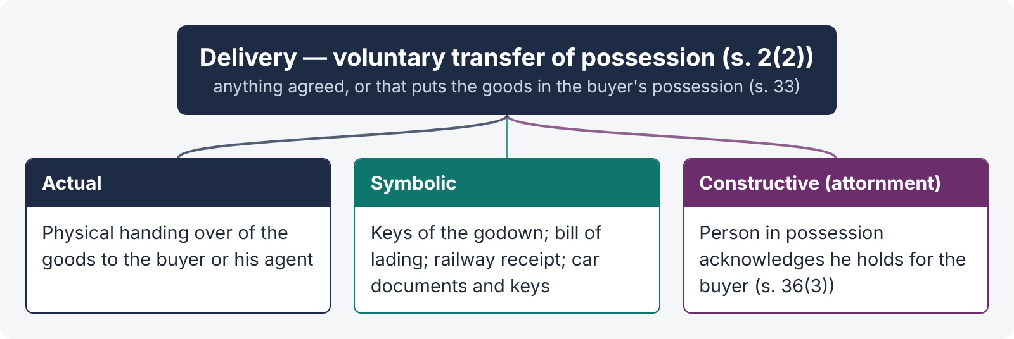
Figure 8 · The three kinds of delivery
Kind | Meaning and examples
Actual (physical) | The goods are physically handed over to the buyer or his agent — handing a television to the buyer at the counter.
Symbolic | Something is handed over that gives control of the goods — the keys of a godown containing the goods; a bill of lading, railway receipt or other document of title (s. 2(4)); the registration book and keys of a car.
Constructive (attornment) | There is no physical change of hands, but the person in possession acknowledges that he now holds the goods for another: (i) the seller agrees to hold the goods as the buyer's bailee; (ii) the buyer, already in possession as bailee, begins to hold as owner; (iii) a third person (warehouseman) acknowledges to the buyer that he holds for him — "there is no delivery by seller to buyer unless and until such third person acknowledges to the buyer that he holds the goods on his behalf" (s. 36(3)).

10.3 Rules as to delivery — ss. 33 to 40
s. | Rule
34 | Part delivery in progress of delivery of the whole has the same effect, for passing property, as delivery of the whole; but part delivery with an intention of severing it from the whole does not operate as delivery of the rest.
35 | Buyer to apply — apart from express contract, the seller is not bound to deliver until the buyer applies for delivery.
36(1) | Place — as agreed; otherwise goods sold are delivered at the place where they are at the time of sale; goods agreed to be sold at the place where they are at the time of the agreement, or, if not then in existence, where they are manufactured or produced. Whether the buyer collects or the seller sends depends on the contract.
36(2) | Time — if the seller must send the goods and no time is fixed, within a reasonable time.
36(3) | Goods with a third person — no delivery until he acknowledges to the buyer that he holds on his behalf (attornment); documents of title operate as usual.
36(4) | Reasonable hour — demand or tender of delivery may be treated as ineffectual unless made at a reasonable hour.
36(5) | Expenses of putting the goods into a deliverable state — borne by the seller, unless otherwise agreed.
37(1) | Short delivery — the buyer may reject; if he accepts, he pays at the contract rate.
37(2) | Excess delivery — the buyer may accept the contract quantity and reject the rest, or — if the goods delivered are such that it is difficult or time consuming to separate the quantity contracted for (Pakistani addition, 1994) — reject the whole; if he accepts the whole, he pays at the contract rate.
37(3) | Mixed goods of a different description — accept those that conform and reject the rest, or reject the whole.
37(4) | Subject to usage of trade, special agreement or course of dealing.
38(1) | Instalments — unless otherwise agreed, the buyer is not bound to accept delivery by instalments.
38(2) | In an instalment contract with separate payments, whether a breach as to one or more instalments is a repudiation of the whole or a severable breach (compensation only) depends on the terms and circumstances — chiefly the ratio of the breach to the whole and the likelihood of repetition (Maple Flock Co. v. Universal Furniture Products [1934] 1 KB 148).
39(1) | Delivery to a carrier or wharfinger for transmission to the buyer is prima facie delivery to the buyer.
39(2) | The seller must make a reasonable contract with the carrier; otherwise the buyer may decline to treat delivery to the carrier as delivery to himself, or hold the seller liable.
39(3) | Sea transit — the seller must give notice enabling the buyer to insure; otherwise the goods are at the seller's risk during sea transit.
40 | Where the seller agrees to deliver at a distant place at his own risk, the buyer still bears the risk of deterioration necessarily incident to transit.

10.4 Examination, acceptance and rejection — ss. 41 to 44
- Right to examine — s. 41. A buyer to whom goods are delivered which he has not previously examined is not deemed to have accepted them until he has had a reasonable opportunity of examining them to see whether they conform to the contract; and the seller, on tendering delivery, must on request afford that opportunity.
- Acceptance — s. 42. The buyer is deemed to have accepted the goods (i) when he intimates acceptance to the seller; (ii) when, after delivery, he does any act inconsistent with the seller's ownership (e.g., resells or uses them as his own); or (iii) when, after a reasonable time, he retains them without intimating rejection.
- No duty to return rejected goods — s. 43. Unless otherwise agreed, a buyer who rightly refuses to accept need not return the goods; it is enough to intimate refusal to the seller (he holds them as a bailee meanwhile).
- Buyer's refusal or neglect to take delivery — s. 44. Where the seller is ready and willing and requests delivery, and the buyer does not take it within a reasonable time, the buyer is liable for any loss caused and for a reasonable charge for care and custody; if his refusal amounts to repudiation, the seller has his further remedies.
Effect of acceptance: after acceptance in a non-severable contract, a breach of condition can only be treated as a breach of warranty (s. 13(2)) — damages, not rejection.
QUICK RECAP · Chapter 10 in five lines
- Seller delivers; buyer accepts and pays (s. 31); delivery and payment concurrent (s. 32).
- Delivery = voluntary transfer of possession (s. 2(2), s. 33): actual, symbolic (keys, documents of title), constructive (attornment — s. 36(3)).
- Rules: part delivery (s. 34); buyer to apply (s. 35); place, time, reasonable hour, expenses (s. 36); wrong quantity (s. 37 — Pakistani 1994 addition); instalments (s. 38); carrier and sea transit (s. 39); distant place (s. 40).
- Examination (s. 41) before acceptance (s. 42); no duty to return rejected goods (s. 43); buyer's delay — loss and custody charges (s. 44).
- Acceptance converts a condition into a warranty (s. 13(2)).

Chapter 11 · Rights of the unpaid seller against the goods (SGA ss. 45 to 54)

11.1 Who is an unpaid seller — s. 45
"45. (1) The seller of goods is deemed to be an 'unpaid seller' within the meaning of this Act— (a) when the whole of the price has not been paid or tendered; (b) when a bill of exchange or other negotiable instrument has been received as conditional payment, and the condition on which it was received has not been fulfilled by reason of the dishonour of the instrument or otherwise. (2) In this Chapter, the term 'seller' includes any person who is in the position of a seller, as, for instance, an agent of the seller to whom the bill of lading has been indorsed, or a consignor or agent who has himself paid, or is directly responsible for, the price."
A seller who has received part of the price is still an unpaid seller. A seller who has been tendered the full price, or who has accepted a negotiable instrument as absolute payment, is not.

11.2 The rights — s. 46
"46. (1) Subject to the provisions of this Act and of any law for the time being in force, notwithstanding that the property in the goods may have passed to the buyer, the unpaid seller of goods, as such, has by implication of law— (a) a lien on the goods for the price while he is in possession of them; (b) in case of the insolvency of the buyer a right of stopping the goods in transit after he has parted with the possession of them; (c) a right of re-sale as limited by this Act. (2) Where the property in goods has not passed to the buyer, the unpaid seller has, in addition to his other remedies, a right of withholding delivery similar to and co-extensive with his rights of lien and stoppage in transit where the property has passed to the buyer."
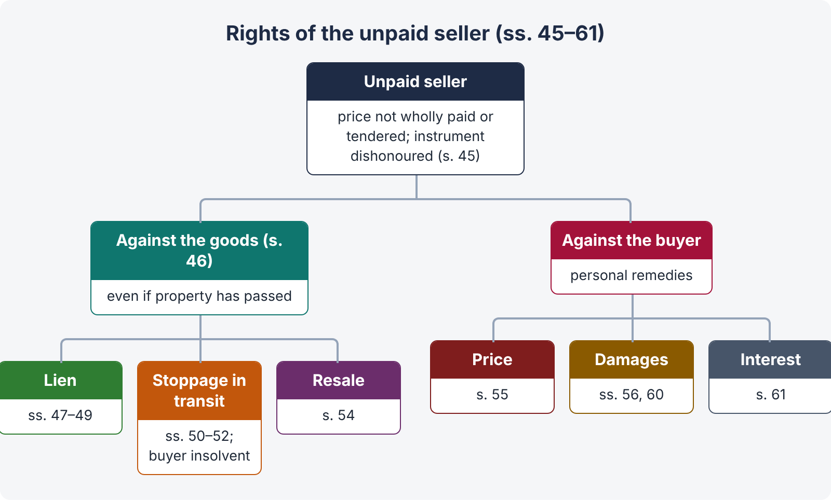
Figure 9 · Rights of the unpaid seller
Besides these rights against the goods, he has rights against the buyer personally: a suit for the price (s. 55), for damages for non-acceptance (s. 56), for interest (s. 61), and for damages for anticipatory repudiation (s. 60).

11.3 The lien — ss. 47 to 49
When available — s. 47(1). The unpaid seller in possession may retain them until payment or tender of the price —
- where the goods have been sold without any stipulation as to credit;
- where they have been sold on credit, but the term of credit has expired; or
- where the buyer becomes insolvent (even during the credit period).
The seller may exercise his lien even though he is in possession as agent or bailee for the buyer (s. 47(2)) — e.g., where property has passed and he holds the goods for the buyer.
Part delivery — s. 48. After part delivery, the seller may exercise his lien on the remainder, unless the part delivery shows an agreement to waive the lien.
Loss of lien — s. 49. The unpaid seller loses his lien —
- when he delivers the goods to a carrier or other bailee for transmission to the buyer without reserving the right of disposal;
- when the buyer or his agent lawfully obtains possession; or
- by waiver.
He does not lose his lien merely because he has obtained a decree for the price (s. 49(2)).
Nature of the lien. It is a possessory lien for the price only (not for storage charges or other debts); it does not by itself rescind the contract (s. 54(1)).

11.4 Stoppage in transit — ss. 50 to 52
"50. Subject to the provisions of this Act, when the buyer of goods becomes insolvent, the unpaid seller who has parted with the possession of the goods has the right of stopping them in transit, that is to say, he may resume possession of the goods as long as they are in the course of transit, and may retain them until payment or tender of the price."
Conditions: (i) the seller is unpaid; (ii) he has parted with possession; (iii) the goods are in transit; (iv) the buyer is insolvent (s. 2(8) — ceased to pay debts in the ordinary course, or cannot pay as they fall due).
Duration of transit — s. 51.
- Goods are in transit from delivery to a carrier or other bailee for transmission to the buyer until the buyer or his agent takes delivery from the carrier (s. 51(1)).
- If the buyer obtains delivery before arrival at the destination, transit ends (s. 51(2)).
- If, after arrival, the carrier acknowledges to the buyer that he holds the goods on his behalf, transit ends (s. 51(3)).
- If the goods are rejected by the buyer and the carrier keeps them, transit continues (s. 51(4)).
- Goods on a ship chartered by the buyer — whether the master holds as carrier or as the buyer's agent depends on the circumstances (s. 51(5)).
- If the carrier wrongfully refuses to deliver to the buyer, transit ends (s. 51(6)).
- After part delivery, the remainder may be stopped unless the part delivery shows an agreement to give up possession of the whole (s. 51(7)).
How effected — s. 52. By taking actual possession, or by notice to the carrier or bailee (or to his principal, in time to prevent delivery). The carrier must then re-deliver to the seller, at the seller's expense.
Point | Lien | Stoppage in transit
Possession | Seller retains possession | Seller has parted with possession; regains it
Buyer's insolvency | Not necessary (credit expired or no credit is enough) | Essential
Ends | When goods reach carrier / buyer | When transit ends (buyer takes delivery)
Nature | Right to keep | Right to resume possession
Relation | Stoppage begins where lien ends | Extension of the lien

11.5 Effect of sub-sale or pledge by the buyer — s. 53
The seller's lien or right of stoppage is not affected by any sale or other disposition by the buyer, unless the seller has assented (s. 53(1)). But where a document of title has been issued or lawfully transferred to the buyer, and he transfers it to a person taking in good faith and for consideration: if by way of sale, the seller's lien or stoppage is defeated; if by way of pledge, the seller's rights can be exercised only subject to the pledgee's rights (s. 53(1) proviso). In the case of a pledge, the seller may require the pledgee to satisfy his claim first, as far as possible, out of other goods or securities of the buyer in his hands (s. 53(2)) — the principle of marshalling.

11.6 Right of resale — s. 54
- No rescission by lien or stoppage alone — "a contract of sale is not rescinded by the mere exercise by an unpaid seller of his right of lien or stoppage in transit" (s. 54(1)).
- Resale with notice — where the goods are perishable, or the unpaid seller gives notice to the buyer of his intention to resell, and the buyer does not pay or tender the price within a reasonable time, the seller may resell within a reasonable time and recover damages for any loss from the original buyer; the buyer is not entitled to any profit on the resale (s. 54(2)).
- Resale without notice — the seller cannot recover damages, and the buyer is entitled to any profit on the resale (s. 54(2)).
- Title of the second buyer — "the buyer acquires a good title thereto as against the original buyer, notwithstanding that no notice of the re-sale has been given to the original buyer" (s. 54(3)).
- Express reservation — where the seller expressly reserves a right of resale on the buyer's default and resells, the original contract is rescinded, without prejudice to his claim for damages (s. 54(4)).
ILLUSTRATION · The unpaid seller in practice
Sadiq Textiles, Faisalabad, sells 500 bales of cloth to Rehman Traders, Karachi, on 30 days' credit, and sends them by goods train, the railway receipt made out in Rehman's name. While the goods are on their way, Rehman stops paying its debts. Sadiq is an unpaid seller (s. 45); it has parted with possession and so has no lien (s. 49(1)(a)); but the buyer is insolvent and the goods are in transit (ss. 50–51) — Sadiq may stop them by notice to the railway (s. 52). If Rehman had already endorsed the railway receipt to a bank as pledge for a loan, Sadiq's right is subject to the bank's rights (s. 53). Having stopped the goods, Sadiq should give Rehman notice of resale, then resell and claim any shortfall as damages (s. 54(2)).

QUICK RECAP · Chapter 11 in six lines
- Unpaid seller: whole price not paid or tendered, or negotiable instrument dishonoured (s. 45); includes persons in the seller's position.
- Rights against goods: lien, stoppage in transit, resale; withholding delivery where property has not passed (s. 46).
- Lien: no credit / credit expired / buyer insolvent (s. 47); on remainder after part delivery (s. 48); lost by delivery to carrier without reservation, buyer's lawful possession, waiver — not by decree (s. 49).
- Stoppage: buyer insolvent, goods in transit (ss. 50–51 — seven rules); by possession or notice (s. 52).
- Sub-sale / pledge by buyer: no effect unless seller assents, except transfer of a document of title to a bona fide transferee for value (s. 53).
- Resale: not rescission by lien alone; perishable or after notice — damages, no profit to buyer; without notice — no damages, buyer gets profit; second buyer's good title; express reservation rescinds (s. 54).

Chapter 12 · Suits for breach and miscellaneous rules (SGA ss. 55 to 66)

12.1 The seller's remedies against the buyer
- Suit for the price — s. 55. (1) Where property has passed and the buyer wrongfully neglects or refuses to pay; or (2) where the price is payable on a day certain irrespective of delivery, even though property has not passed and the goods have not been appropriated.
- Damages for non-acceptance — s. 56. Where the buyer wrongfully neglects or refuses to accept and pay. The measure, under Contract Act s. 73, is ordinarily the difference between the contract price and the market price at the time and place fixed for acceptance (illus. (c) to s. 73).
- Repudiation before the due date — s. 60. The seller may treat the contract as subsisting and wait, or treat it as rescinded and sue for damages at once (anticipatory breach — Hochster v. De la Tour).
- Interest — s. 61. In the absence of a contrary contract, the court may award interest on the price from the date of tender of the goods or the date the price was payable (s. 61(2)(a)) (see the riba note in Topic 3, Chapter 12).
- Charges for care and custody where the buyer delays taking delivery (s. 44).

12.2 The buyer's remedies against the seller
- Damages for non-delivery — s. 57. Ordinarily the difference between the market price at the time and place of delivery and the contract price (illus. (a) to s. 73).
- Specific performance — s. 58. "Subject to the provisions of Chapter II of the Specific Relief Act, 1877, in any suit for breach of contract to deliver specific or ascertained goods, the Court may, if it thinks fit, on the application of the plaintiff, by its decree direct that the contract shall be performed specifically, without giving the defendant the option of retaining the goods on payment of damages." Granted where damages are not adequate — e.g., unique goods (an antique, a rare manuscript, a special machine).
- Breach of warranty — s. 59. The buyer cannot reject for breach of warranty, but may (a) set it up in diminution or extinction of the price, or (b) sue for damages; and setting up the breach in diminution does not prevent him from suing for further damage.
- Repudiation before due date — s. 60.
- Refund and interest — s. 61. Recovery of money paid where the consideration has failed (e.g., Rowland v. Divall), with interest from the date of payment (s. 61(2)(b)); special damages where recoverable by law (s. 61(1); Contract Act s. 73 second limb).
- Rejection of goods for breach of condition (ss. 12–17, 37), and a suit for recovery of the price paid.

12.3 Auction sales — s. 64
s. 64 | Rule
(1) | Goods put up in lots — each lot is prima facie a separate contract.
(2) | The sale is complete on the fall of the hammer or other customary announcement; until then, any bidder may retract his bid (the bid is an offer — Topic 3, Chapter 2).
(3) | A right to bid may be reserved expressly by or on behalf of the seller; then the seller or one person on his behalf may bid.
(4) | If not notified as subject to a right to bid, the seller may not bid himself or employ anyone to bid, nor may the auctioneer knowingly take such bids; a sale contravening this may be treated as fraudulent by the buyer.
(5) | The sale may be notified to be subject to a reserved or upset price.
(6) | If the seller uses pretended bidding ("puffing") to raise the price, the sale is voidable at the buyer's option.

12.4 Other rules
- Increase or decrease of duty or tax — s. 64A. If customs or excise duty, or sales tax (under the Sales Tax Act 1951, as the Explanation states), is imposed, increased, decreased or remitted after the contract (and the contract is silent), the seller may add the increase to the price, and the buyer may deduct the decrease.
- Reasonable time is a question of fact (s. 63).
- Exclusion of implied terms by agreement, course of dealing or usage (s. 62).
- Savings — s. 66. Existing rights, insolvency rules and non-inconsistent rules of law are saved; and "the provisions of this Act relating to contracts of sale do not apply to any transaction in the form of a contract of sale which is intended to operate by way of mortgage, pledge, charge or other security" (s. 66(3)).
QUICK RECAP · Chapter 12 in five lines
- Seller: price (s. 55 — property passed, or price due on a day certain); damages for non-acceptance (s. 56); anticipatory breach (s. 60); interest (s. 61); custody charges (s. 44).
- Buyer: damages for non-delivery (s. 57); specific performance of specific / ascertained goods (s. 58); warranty — diminution of price or damages (s. 59); refund on failure of consideration and interest (s. 61); rejection for breach of condition.
- Auctions: lots, fall of the hammer, retraction, reserved right to bid, puffing voidable (s. 64).
- Duty and sales tax changes adjust the price (s. 64A); reasonable time a question of fact (s. 63).
- Security transactions in the form of sales are outside the Act (s. 66(3)).

Chapter 13 · Legal maxims for Topic 4 — at a glance
Maxim | Meaning | Where it applies
Qui facit per alium facit per se | He who acts through another acts himself | Agency — principal bound by the agent's acts (s. 226)
Delegatus non potest delegare | A delegate cannot delegate | Sub-agents (s. 190)
Respondeat superior | Let the principal answer | Principal's liability for agent's fraud in the course of business (s. 238; Lloyd v. Grace, Smith)
Omnis ratihabitio retrotrahitur et mandato priori aequiparatur | Every ratification relates back and is equivalent to a prior authority | Ratification (s. 196; Bolton Partners v. Lambert)
Nemo dat quod non habet | No one gives what he does not have | SGA s. 27 and its exceptions
Caveat emptor | Let the buyer beware | SGA s. 16 — exceptions in ss. 14–17 and s. 16A (Pakistan)
Res perit domino | The thing perishes for its owner | Risk follows property (SGA s. 26)
Uberrimae fidei | Utmost good faith | Insurance; a guarantee requires disclosure of unusual facts (s. 143)
Indemnis | Unhurt — to make whole | Indemnity (ss. 124–125; s. 145)
Accessorium sequitur principale | The accessory follows the principal | The surety's liability is co-extensive with, and follows, the principal debt (s. 128)
Vigilantibus non dormientibus jura subveniunt | The law helps the vigilant | Mere forbearance does not discharge a surety (s. 137), but a binding promise to give time does (s. 135)
Nullus commodum capere potest de injuria sua propria | No one may profit from his own wrong | Agent's secret profits (ss. 215–216); creditor impairing surety's remedy (s. 139)
Ex turpi causa non oritur actio | No action from a base cause | No indemnity for criminal acts (s. 224)
Nemo debet locupletari ex aliena jactura | No one should be enriched at another's loss | Surety's indemnity (s. 145); finder's charges (s. 168); bailor's increase (s. 163)

Chapter 14 · The great distinctions of Topic 4
Pair | First | Second
Indemnity vs guarantee | Two parties; primary liability; save from loss (s. 124) | Three parties; secondary liability on default (s. 126)
Specific vs continuing guarantee | Single transaction; ends on payment | Series of transactions (s. 129); revocable for the future (ss. 130–131)
Variance (s. 133) vs forbearance (s. 137) | Change in terms without consent — discharges surety | Mere inaction — does not discharge
Promise to give time to debtor (s. 135) vs to a third person (s. 136) | Discharges the surety | Does not discharge
Bailment vs pledge | Delivery for any purpose; return the goods (s. 148) | Delivery as security; power of sale on default (ss. 172, 176)
Pledge vs hypothecation | Possession with the creditor | Possession with the debtor; charge only
Particular vs general lien | Specific goods improved by labour or skill (s. 170) | Any goods, for the general balance — bankers, factors, wharfingers, attorneys, policy-brokers (s. 171)
Gratuitous vs non-gratuitous bailment | Recall any time with indemnity (s. 159); ends on death (s. 162) | For reward; bailor liable for unknown faults (s. 150)
Agent vs servant | Represents the principal in dealings with third persons | Works under control; no general power to contract
Sub-agent vs substituted agent | Agent's agent; answerable to the agent (s. 192) | Principal's agent named by the agent (s. 194)
Revocable vs irrevocable agency | Revocable before exercise (s. 203) | Coupled with interest (s. 202); partly exercised (s. 204)
Disclosed vs undisclosed principal | Third party deals knowingly with an agent | Third party thinks the agent is the principal (ss. 231–232)
Sale vs agreement to sell | Property passes now; price suit; buyer's risk | Property passes later / on condition; damages; seller's risk (s. 4)
Sale vs hire-purchase | Buyer bound to buy | Hirer has an option; not "agreed to buy" (Helby v. Matthews)
Condition vs warranty | Essential; rejection + damages (s. 12(2)) | Collateral; damages only (s. 12(3))
Specific vs unascertained goods | Identified and agreed at contract (s. 2(14)) | Generic; no property until ascertained (s. 18)
Delivery vs transfer of property | Transfer of possession (s. 2(2)) | Transfer of ownership (ss. 18–26)
Actual vs symbolic / constructive delivery | Physical handing over of the goods | Keys or documents of title (symbolic); attornment by the person in possession (constructive — s. 36(3))
Lien vs stoppage in transit | Seller keeps possession; no insolvency needed (s. 47) | Seller resumes possession; buyer insolvent; goods in transit (s. 50)
Resale with vs without notice | Damages recoverable; buyer gets no profit (s. 54(2)) | No damages; buyer gets the profit
Voidable title (s. 29) vs void contract | Rogue's buyer in good faith before rescission gets title (Phillips v. Brooks) | No title passes (Cundy v. Lindsay)
Suit for price vs damages for non-acceptance | Property passed or price due on a day certain (s. 55) | Otherwise (s. 56)

Chapter 15 · Exam technique for Topic 4

15.1 Guarantee problems — the six questions
- Is there a guarantee at all — or an indemnity? (Who is primarily liable? s. 124 vs s. 126.)
- Is it valid — consideration (s. 127), free consent (ss. 142–143), condition precedent (s. 144), form and proof (Art. 17, 79 QSO), capacity (ultra vires for companies)?
- What kind — specific or continuing (s. 129)? Was it revoked (ss. 130–131)?
- Extent of liability — co-extensive, limited by the contract (s. 128); immediate (Bank of Bihar).
- Has the surety been discharged — ss. 133–139, 141?
- What are the surety's rights — ss. 140, 141, 145–147?

15.2 Agency problems — the five questions
- Was there an agency — and how was it created (express, implied, estoppel, necessity, ratification)?
- Did the agent act within his authority — actual, incidental (s. 188), ostensible (s. 237)?
- Who is liable to the third party — the principal (s. 226), the agent personally (s. 230), or either (s. 233)?
- Did the agent breach a duty — directions, skill, accounts, self-dealing (s. 215), secret profit (s. 216)?
- Has the agency terminated, and when did termination take effect (ss. 201–210)?

15.3 Sale of goods problems — the four questions
- What kind of contract and goods — sale or agreement to sell; specific or unascertained (ss. 4, 18)?
- Has property (and risk) passed — ss. 19–26?
- Was a condition or warranty broken — ss. 12–17, 16A; has the buyer accepted (ss. 13(2), 42)?
- Title and third parties — nemo dat and exceptions (ss. 27–30); unpaid seller's rights (ss. 45–54); remedies (ss. 55–61).
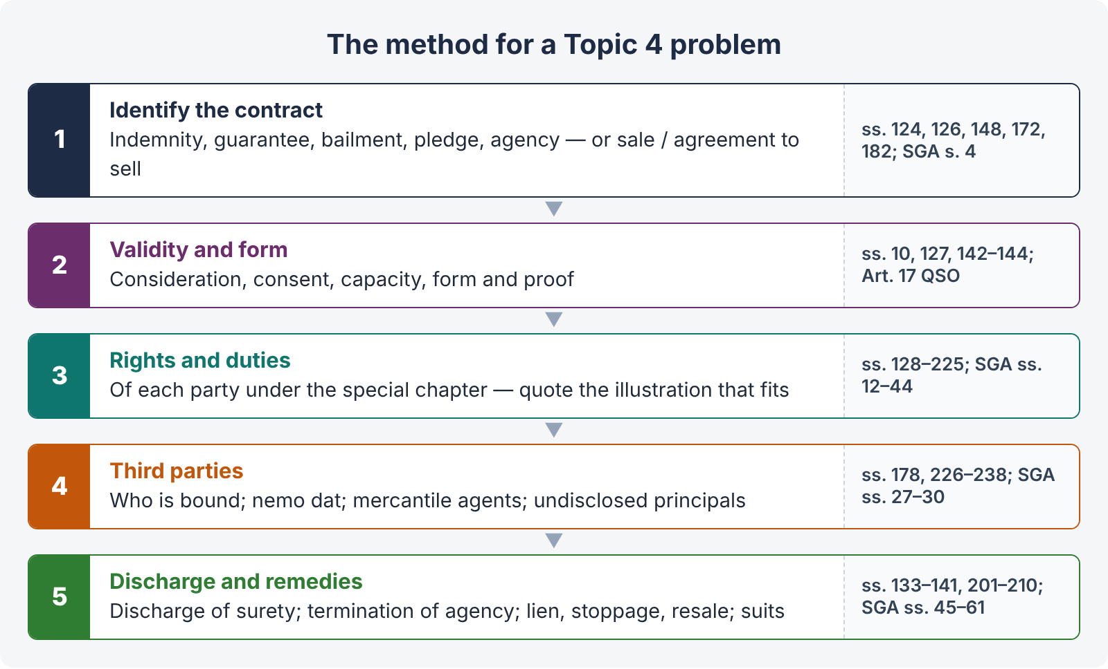
Figure 10 · The method for a Topic 4 problem

15.4 A 3-hour plan (reminder)
Ten minutes reading; about 33 minutes per 20-mark question; a quick answer map; quote the Act and its illustrations; one case per point; Pakistani features (s. 16A, s. 13(2), ss. 178–178A, Art. 17 QSO); a clear conclusion; ten minutes for review.

Chapter 16 · Last-night revision sheet
QUICK RECAP · The 40 points of Topic 4
- Indemnity: save from loss caused by the promisor or another (s. 124); narrower than English law (Adamson v. Jarvis).
- Indemnity-holder recovers damages, prudent costs and prudent compromises (s. 125); may sue once liability is absolute (Gajanan Moreshwar).
- Guarantee: perform the promise / discharge the liability of a third person on default (s. 126); oral or written; Art. 17 QSO attestation.
- Consideration for the principal debtor's benefit suffices (s. 127); past consideration without request — void (illus. (c)).
- Continuing guarantee (s. 129) — revoked as to the future by notice (s. 130) or death (s. 131).
- Surety's liability co-extensive (s. 128) and immediate — no need to sue the debtor first (Bank of Bihar v. Damodar Prasad).
- Bank guarantees independent; injunction only for fraud or irretrievable injustice.
- Discharge by variance (s. 133 — illus. (a)–(e)) and by release of the principal debtor (s. 134).
- Composition, giving time, or promise not to sue — discharges (s. 135); not with a third person (s. 136); not mere forbearance (s. 137).
- Release of a co-surety does not discharge others (s. 138); creditor impairing the surety's remedy discharges (s. 139).
- Loss of securities discharges to their value (s. 141); invalid guarantees — misrepresentation, concealment, co-surety not joining (ss. 142–144).
- Surety's rights: subrogation (s. 140), securities (s. 141), indemnity (s. 145), contribution (ss. 146–147).
- Bailment: delivery of goods for a purpose, on a contract to return (s. 148); possession, not ownership; not a bank deposit of money.
- Bailor's duty to disclose known faults; hirer liable even for unknown faults (s. 150).
- Bailee's care — ordinary prudence in all bailments (s. 151); no liability if taken (s. 152); limiting clauses doubtful (Lily White).
- Unauthorised use — voidable (s. 153) and strict liability (s. 154); mixing (ss. 155–157).
- Return without demand; risk after default (ss. 160–161; Shaw v. Symmons); increase to the bailor (s. 163).
- Gratuitous loan recallable with indemnity (s. 159); gratuitous bailment ends on death (s. 162).
- Liens: particular (s. 170 — labour or skill; credit excludes) and general (s. 171 — five classes).
- Finder: bailee's duties (s. 71); retain for expenses; sue for offered reward (s. 168); sell if perishing or charges reach two-thirds (s. 169).
- Pledge: bailment as security (s. 172); retain for debt, interest, expenses (s. 173); subsequent advances presumed (s. 174).
- On default: sue and retain, or sell after reasonable notice; balance / surplus (s. 176; Lallan Prasad); redeem before sale (s. 177).
- Pledge by mercantile agent (s. 178), by voidable-title holder (s. 178A), limited interest (s. 179).
- Agent: represents another (s. 182); minor agent binds principal (s. 184); no consideration needed (s. 185).
- Authority express or implied (ss. 186–187 — Quetta shop); incidental (s. 188); emergency (s. 189; Swaffield; Springer).
- Ostensible authority (s. 237; Freeman & Lockyer); powers of attorney construed strictly.
- Ratification: existing competent principal (Kelner v. Baxter), disclosed principal (Keighley Maxsted), full knowledge (s. 198), whole transaction (s. 199), no injury to third parties (s. 200), relates back.
- Sub-agent (ss. 190–193) vs substituted agent (ss. 194–195).
- Agent's duties: directions / custom (s. 211), skill (s. 212), accounts (s. 213), communicate (s. 214), pay over (s. 218).
- s. 215 — self-dealing without informed consent: repudiate if concealment or disadvantage; s. 216 — secret profits (Armstrong v. Jackson).
- Agent's rights: retainer, remuneration, lien, indemnity (ss. 217–223); none for criminal acts (s. 224); injury (s. 225).
- Principal bound (s. 226); excess of authority (ss. 227–228); notice (s. 229); agent's fraud (s. 238).
- Agent personally liable (s. 230 — foreign principal, undisclosed name, principal not suable); undisclosed principal (ss. 231–232); election (s. 233); pretended agent (s. 235).
- Termination (s. 201); coupled with interest (s. 202); partly exercised (s. 204); compensation and notice (ss. 205–206); effective on knowledge (s. 208).
- Sale vs agreement to sell (s. 4); goods include electricity, water, gas (s. 2(7)); perishing (ss. 7–8); price (ss. 9–10).
- Condition vs warranty (s. 12); waiver / acceptance (s. 13 — Pakistani text); title (s. 14; Rowland v. Divall); description (s. 15).
- Caveat emptor and exceptions: fitness (Priest v. Last), merchantable (Grant), trade name (Baldry), usage, sample (s. 17); s. 16A duty to disclose defects; exclusion (s. 62; Wallis v. Pratt).
- Property: unascertained (s. 18), intention (s. 19), rules ss. 20–24, right of disposal (s. 25), risk (s. 26 — res perit domino).
- Nemo dat (s. 27) and exceptions: estoppel, mercantile agent, joint owner, voidable title, seller / buyer in possession (ss. 27–30); finder, pawnee, unpaid seller resale.
- Delivery (ss. 2(2), 33–40 — actual, symbolic, constructive); acceptance (ss. 41–44); unpaid seller — lien, stoppage, resale (ss. 45–54); suits (ss. 55–61); auctions (s. 64).

